**U3a Physics: Atomic and Nuclear Physics**

**Session 7 (part 1)**

**Atomic Structure revisited**

Rutherford’s Alpha particle scattering experiments led to the conclusion that the atom was made up of an inner positive nucleus, surrounded by orbiting negative electrons:

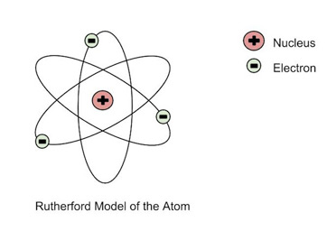 [Diagram credit study.com]

The Rutherford model of the atom was modified by Niels Bohr allowing the electrons to move in fixed orbits around the nucleus (and not anywhere in between). Electrons can jump from one orbit to another by emitting or absorbing energy:

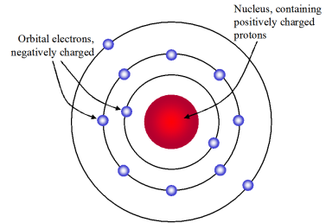[Diagram credit: sutori.com]

Spectral lines provide evidence for this model. Each element has a different set of energy levels and therefore a different emission spectrum.

**However, there are problems with this model**, including:

* The Bohr model does not accurately describe larger atoms.  It works very well for atoms with only one electron, like H or He, but not for multi-electron atoms.
* The orbiting electrons are moving charges and therefore should radiate electromagnetic waves (as mentioned in last week’s session). This would mean that the electrons would therefore lose energy and spiral into the nucleus. There was a need to explain why this doesn’t happen, why the atom is, in fact, stable.

This issue of instability was addressed by Bohr in 1913. He combined the “planetary” model with the quantum ideas put forward by Max Planck at the turn of the century. Bohr no longer referred to orbits but only to ‘stationary states’. Atoms could exist in a stationary state and be stable. Spectral lines were a result of transitions between these stationary states. Bohr’s model was the first step towards an atom that is described by **quantum mechanics**. It no longer followed classical laws.

In the late 1920s, the quantum mechanics of Schrödinger and Heisenberg offered two further developments to Bohr’s model. Ref: [IOP Spark]

**Max Planck and Quanta of energy**

In 1900 German physicist Max Planck introduced his revolutionary idea, now known as the Planck postulate, that electromagnetic energy can be emitted only in quantised form or in chunks (quanta). In other words, the energy, E, can only be a multiple of an elementary unit, h, where *h* is Planck's constant.

***E* = *h* × *f***  (where f is the frequency of the em wave)

Referring back to the Bohr model, the energy, E, of a photon of light emitted when an electron falls from energy level E2 To energy level E1 is given by

***E = E*2 – *E*1 = *h*  ×  *f***