**U3a Physics: Atomic and Nuclear Physics**

**Session 2: Atomic Structure**

In 1909, Ernest Rutherford did an experiment to test the plum pudding model of the atom. His two students, Hans Geiger and Ernest Marsden, directed a beam of alpha particles at a very thin gold leaf (10-6m thick) suspended in a vacuum. The vacuum is needed so that the alpha particles don’t collide with air molecules on the way to the gold foil. Rutherford knew that an alpha particle is a helium nucleus and that it has a range of about 5cm in air.

Gold was used because it was the only metal that could be rolled out to be very thin without cracking.

Radium was used as the source of alpha particles, which it emits as it undergoes radioactive decay (more on this in a later session).

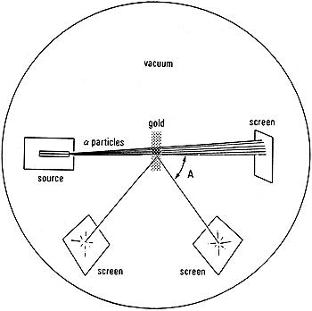

[Credit: https://spark.iop.org/alpha-particle-scattering]

Results:

* most of the alpha particles passed straight through the foil
* a small number were deflected by large angles as they passed through the foil
* a very small number of alpha particles came straight back off the foil

Conclusions:

* the fact that most alpha particles went straight through the foil is evidence for the atom being mostly empty space
* a small number of alpha particles being deflected suggested that there is a concentration of positive charge in the atom - like charges repel, so the positive alpha particles were being repelled by positive charges
* the very small number of alpha particles coming straight back suggested that the positive charge and mass are concentrated in a tiny volume in the atom (the nucleus) - the tiny number doing this means the chance of being on that exact collision course was very small, and so the 'target' being aimed at had to be equally tiny

Rutherford said: *"It was as if you fired a 15-inch shell at a sheet of tissue paper and it came back to hit you."*

He concluded that the atom consists of a tiny positive nucleus surrounded by negative electrons.

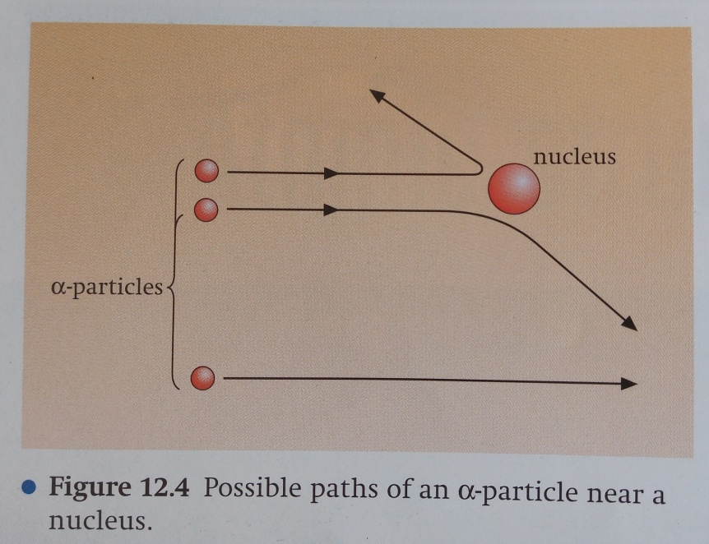

[Diagram from: “Physics 2” by David Sang]

If the alpha particle goes through the gold foil relatively far from a nucleus, it will pass straight through undeflected. If it passes near a nucleus it is deflected from its path but it continues through to the other side of the foil. If it impacts more-or-less head-on with the nucleus, it rebounds back through an angle of greater than 90°. It has since been shown that the repulsion of the alpha particle is due to the electrostatic repulsion between the positive charge on the alpha particle and the positive charge on the gold nucleus. The closer the alpha particle gets to the nucleus, the greater is this repulsion.

The make-up of the nucleus, ie protons and neutrons, wasn’t discovered until later. Rutherford discovered the proton in 1919, Chadwick discovered the neutron in 1932.

Protons carry a positive charge, neutrons are neutral, electrons negative. A neutral atom has the same number of electrons as protons. Protons and neutrons have approximately the same mass but are about 1800 times the mass of the electron.

Protons and neutrons are collectively called *nucleons*.

**Simple model of the atom**

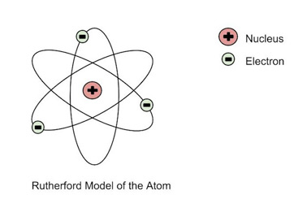[Diagram credit study.com]

The simplest atom is hydrogen (H), with one proton (p) and no neutrons (n) in its nucleus, and one electron (e). Helium (He) is the next simplest with 2p, 2n and 2e.

**Proton and nucleon numbers**

Different elements have different numbers of protons in their nuclei, eg Lithium has 3, beryllium has 4, boron has 5, carbon has 6.

The number of protons = **atomic number** or proton number, Z

The number of neutrons + protons = **mass number** or nucleon number, A

Lithium has 3 protons and 4 neutrons **∴** its mass number is 7.

A shorthand way of writing this is 7 3Li. In general, for an element X, A ZX

A specific combination of protons and neutrons in the nucleus is called a nuclide.

In 1869 Russian chemist Dimitri Mendeleev started the development of the periodic table, arranging elements according to their atomic mass. He predicted the discovery of other elements, and left spaces open in his periodic table for them.

Go to this web page to see an interactive version of the periodic table:

[**https://www.rsc.org/periodic-table/**](https://www.rsc.org/periodic-table/)

**Isotopes**

The number of protons in a nucleus determines which element it is. Helium always has 2, oxygen has 8...

The number of neutrons, however, can vary. For example, there are 3 naturally occurring forms of neon, each with 10 protons, but with 10, 11 and 12 neutrons respectively. These are **isotopes** of neon.

Neutrons have no charge and different neutron numbers have no effect on the chemical properties of the atom, so isotopes of the same element have the same chemical properties, although their nuclear and physical properties (eg density, boiling point) will vary.

Hydrogen has three important isotopes, each with only one proton:

Protium, the main form of hydrogen, has no neutrons

Deuterium, which is a naturally occurring isotope of hydrogen, has 1 proton

Tritium has 2 protons. It is produced naturally in the upper atmosphere when cosmic rays strike nitrogen molecules in the air. It is also produced during nuclear weapons explosions, and as a by-product in nuclear reactors.