**U3a Physics: Atomic and Nuclear Physics**

**Session 3: Waves**

A wave is a “disturbance that moves through a medium”. It is defined in the Encyclopedia Britannica as “A propagation of disturbances from place to place in a regular and organised way”.

Waves that move through a material (or a vacuum) are **progressive waves**.

Waves carry **energy** from one place to another.

Waves can be described as oscillations, or vibrations, about a rest position. For example:

* sound waves cause air particles to vibrate back and forth
* ripples cause water particles to vibrate up and down

The direction of these oscillations is the difference between **longitudinal** or **transverse** waves. In longitudinal waves, the vibrations are parallel to the direction of wave travel (the direction of propagation of the wave). In transverse waves, the vibrations are at right angles to the direction of wave travel.

We demonstrated both of these kinds of waves during the session using a slinky spring.

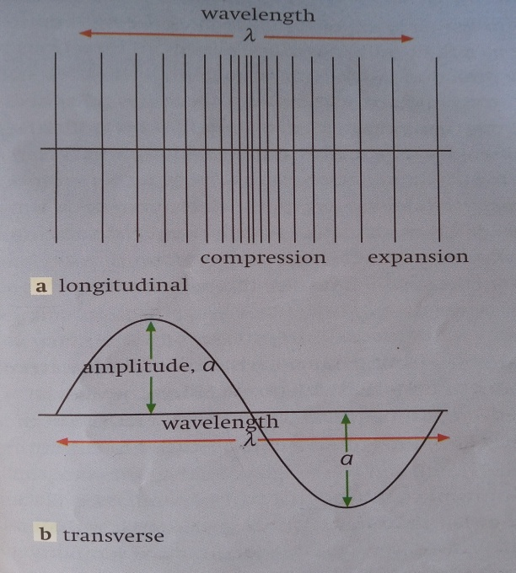

[Credit: Physics 1 by Sang, Gibbs and Hutchings]

Examples of transverse waves include:

* ripples on the surface of water
* vibrations on a guitar string
* electromagnetic waves – eg light waves, X-rays, radio waves

Examples of longitudinal waves include:

* sound waves

Some definitions:

The distance from any point on the wave to the next similar point (eg peak to peak) is the **wavelength, λ**.

The number of waves passing a given point in 1second is the **frequency**, **f** or **ν**. Frequency is measured in hertz (Hz) where 1 Hz is one wave per second (1 cycle per second).

For sound, a bigger frequency means a higher note.

Light of a higher frequency is closer to the blue end of the visible spectrum than light of a lower frequency.

The distance of a point on the wave from its undisturbed (middle) position is its **displacement** and the maximum displacement is the **amplitude**, **a**, of the wave.

The time taken for one complete wave to pass a given point is the **period**, **T**, of the wave. It is measured in seconds.

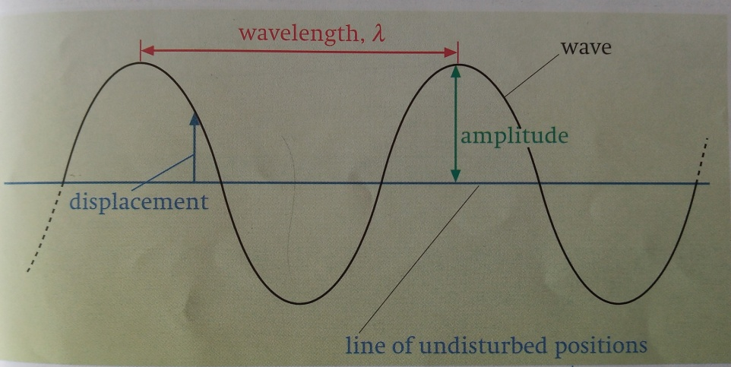

The diagram above shows a graphical way of representing a wave. A wave of this particular shape is known as a sine wave.

The wave equation

It can be shown that: wave speed = frequency x wavelength

**c = ν λ**

As well as being categorised as either transverse or longitudinal, waves can also be grouped depending on whether they are **mechanical** or **electromagnetic**.

A mechanical wave needs a medium through which to travel (eg a sound wave travelling through air or a water wave travelling across the surface of a pond).

An electromagnetic wave does not need a medium and can travel across a vacuum. Examples of em waves are X-rays, visible light, radio waves. We know that they can travel through a vacuum because light and heat (Infra red) radiation arrives at the earth’s surface having travelled across space from the sun.

**During next week’s session** we will consider the properties of waves, including reflection, refraction, diffraction and interference. We will also consider the idea that light (and all em waves) can be considered to sometimes exhibit wave-like properties and sometimes particle-like properties... also that particles, like electrons, can exhibit wave-like behaviour).