**U3a Physics: Atomic and Nuclear Physics**

**Session 4**

**Wave Properties**

All waves can undergo reflection, refraction and diffraction and can produce interference patterns under the right circumstances.

**Reflection**: Waves can be reflected at the boundary between two different materials. Light is reflected from a mirror, for example, The reflection of sound (eg from a wall) is an echo.

The law of reflection states that: angle of incidence = angle of reflection (see diagram below)

For example, if a light ray hits a surface at 32°, it will be reflected at 32°.

The angles of incidence and reflection are measured between the light ray and the normal - an imaginary line at 90° to the surface. The diagram below shows a light ray being reflected at a plane (flat) mirror.

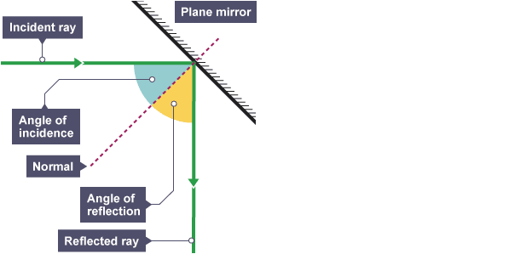

[Credit: BBC Bitesize]

**Refraction**: Different materials have different densities - this can cause waves, such as light, to change direction at the boundary between materials. This change in direction is called refraction.

Waves change speed when they pass across the boundary between two different substances, such as light waves refracting when they pass from air to glass. This causes them to change direction and this effect is called refraction.

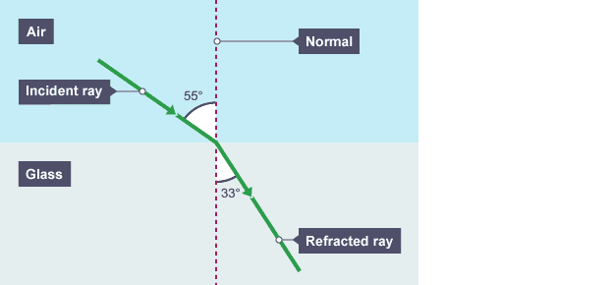

[Credit: BBC Bitesize]

Water waves refract when they travel from deep water to shallow water (or vice versa). This can be seen in the diagram below where water waves are moving through an area of deeper water towards an area of shallow water. NB the waves in this diagram are represented as a series of wave fronts moving across the water with arrows showing their direction of motion.

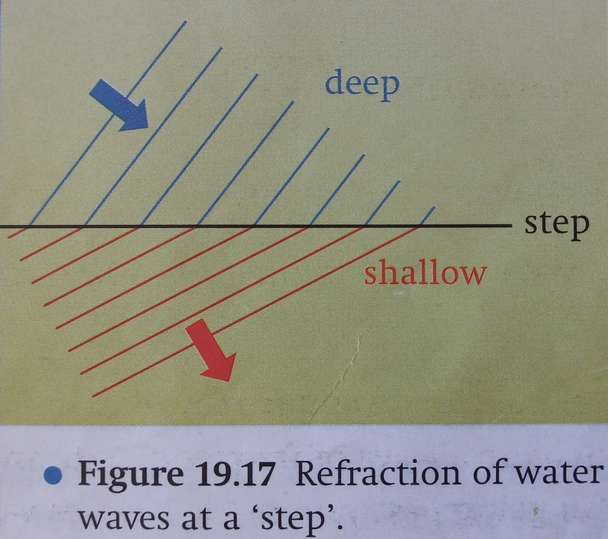

[Diag from “Physics 1” by Sang, Gibbs and Hutchings]

**Diffraction**: Waves spread out when they pass through a gap in a barrier. The amount of spreading depends on the width of the gap compared with the wavelength of the wave. Diffraction is greatest when the gap is of a similar size to the wavelength.

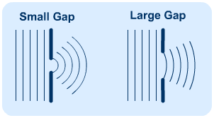

[credit: s-cool.co.uk]

**Interference**: When a wave passes through two small gaps, diffraction occurs at each gap and two waves spread out on the other side. The two waves interfere with one another as shown below, producing an interference pattern. In the case of light waves, the pattern can be seen on a screen, a series of light and dark bands called *interference fringes*.

This is known as Young’s Double Slit Experiment, first carried out by Thomas Young in 1802.

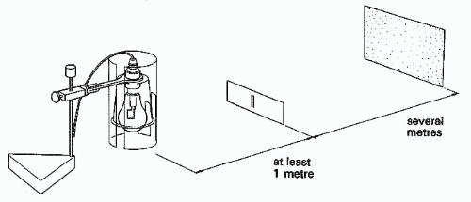

Simple experimental set-up: suitable light source, “double slit” and screen.

[From https://spark.iop.org/collections/youngs-slits]

The principle of superposition predicts that, where the 2 waves arrive at the screen in phase, *constructive interference* occurs and we get a bright band. At point where they arrive out of phase, destructive interference occurs, they cancel one another out and a dark band is seen. In between these bands are degrees of shading.

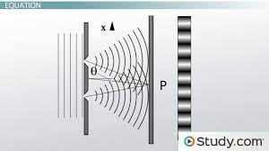

Interference patterns can be produced with other waves. For example, water waves (see below):

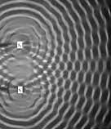 [credit: IOP Science]

The 2 white rectangles on the left are dippers, dipping in and out of the water with the same frequency, producing 2 sets of ripples which overlap one another, resulting in an interference pattern on the water’s surface.