**U3a Physics: Atomic and Nuclear Physics**

**Session 6**

**Electromagnetic radiation**

**What do we already know?**

* The electromagnetic (em) spectrum ranges from γ-rays and X-rays (short wavelength) to radio waves (long wavelength),and includes visible light
* Can travel through a vacuum
* Speed in a vacuum is 3.0 x 108 m/s
* Travel more slowly through other materials (eg glass, water)
* Transfer energy from one place to another (eg thermal energy light energy)
* Are all transverse waves
* Wave speed = frequency x wavelength
* Exhibit all of the expected properties of waves (under certain circumstances): ie. reflection, refraction, diffraction
* Can interfere with one another, obeying the Principle of Superposition
* Can be polarised (see later)
* Some can be dangerous eg γ-rays and X-rays.... but also useful eg medical diagnosis and treatment
* The shorter the wavelength, and therefore the higher the frequency, the more dangerous they are

**Many and varied uses**, in addition to medical uses. For example:

* Sterilisation of food (γ-rays)
* Checking for structural defects (X-rays)
* Producing vitamin D in our skin (UV)
* Allow us to see (visible light)
* Thermographs can detect warm or hot objects (IR)
* Communications (Radio waves, including microwaves)

**Recap: Refraction of light**

When light travels from one medium into another, it changes speed and direction. This is known as refraction. As it travels from a less dense to a more dense medium, it slows down and the light ray bends towards the normal (and vice versa).

An example of this is illustrated in the diagram below. An object at the bottom of a pool of water, when viewed from above, appears to be closer to the surface than it really is. The light from the object bends at the surface of the water and appears to have come from a point above the object. Its *real depth* and its *apparent depth* are indicated on the diagram.

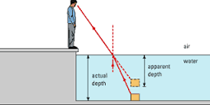

[Image from https://www.toppr.com/ask/content/concept/real-depth-and-apparent-depth-271085/]

**Polarisation**

The vibrations associated with em waves are perpendicular to the direction of propagation (direction of travel) of the wave.

These waves can travel through a vacuum, so do not need a medium for propagation, therefore the vibrations cannot be vibrations of particles of the medium (unlike sound waves, for example, in which the particles of the medium are vibrating).

In fact, em radiation consists of vibrations of electric and magnetic fields travelling through space.

Un-polarised light, like light from the sun, or a lamp, has vibrations in all directions at right angles to the direction of propagation:

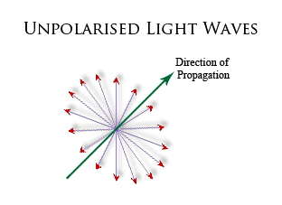[https://www.nightlase.com.au/?pg=resources&t=polarisation]

All transverse waves can be polarised. If light passes through a sheet of Polaroid, it becomes polarised. Only vibrations in one direction can get through, and the light is said to be *plane-polarised*.

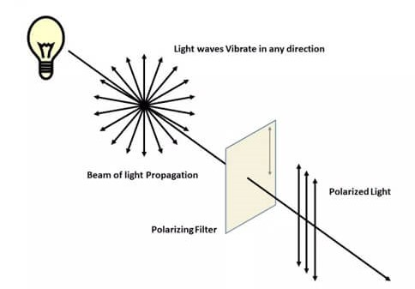

**Polarisation of light**

[https://diffzi.com/polarized-light-vs-unpolarized-light/]

**Historical**

**(1) Corpuscular theory of light**

This theory was thought to have originated with Descartes in 1637 and was pioneered by Newton in 1672. It states that light is made up of small discrete particles called "corpuscles" (little particles) This theory could explain reflection (think of balls bouncing from a wall) but couldn’t explain the phenomena of refraction, diffraction and interference.

**(2) Huygen’s Wave theory of light**

In 1678, Dutch physicist Christiaan Huygens proposed an alternative theory: that light was a wave. He was able to explain reflection and refraction using his theory. In 1803, the experiment conducted by Thomas Young on the interference of light proved that light did exhibit wave-like properties.

The characteristic properties of waves are that they all show reflection, refraction, diffraction and interference. Particle models of light explain reflection and refraction, **so diffraction and interference are considered the defining characteristics of waves.**