**U3a Physics: Atomic and Nuclear Physics**

**Session 7 (part 2)**

**Photoelectric Effect**

**Conclusion from last week:** Light (and other em radiation) exhibits all of the properties associated with **waves**.

**BUT.....**

In **1887**, German physicist Heinrich Hertz noticed, during experiments on radio waves that shining a beam of ultraviolet light onto a metal plate could cause it to spark across a gap.

**The photoelectric effect**

If a negatively-charged metal surface (eg zinc) is exposed to em radiation of a suitable frequency (eg UV), it will emit electrons. This is an immediate effect, however weak the intensity of the radiation is.

This only happens if the radiation is of a high enough frequency. If the same metal surface was irradiated with white light, no electrons would be emitted, however bright (intense) the light and however long it shines for.

When this effect was discovered physicists found it very hard to explain. At the time it was believed that the light waves arriving at the metal would be carrying their energy spread out along the wave front and they couldn’t see why weak UV radiation caused the electrons to be emitted whereas intense white light did not.

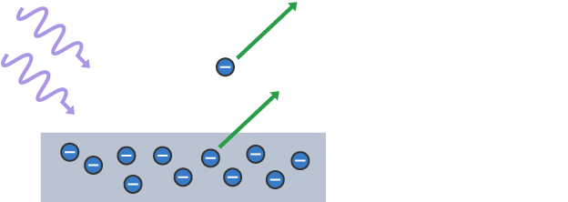

[Diagram credit: BBC Bitesize]

**Einstein’s explanation**

Einstein came up with an explanation based on the idea of light as photons.

Metals have electrons that are not very tightly bound to the atoms and are free to move through the metal. When a photon of light strikes the surface, it can give its energy to an electron to cause it to leave the surface of the metal. Einstein suggested that a single photon could provide all of the energy needed for the electron to escape. The energy needed would have to be greater than a certain value, a threshold value, needed for the electron to escape the surface (ie for *photoemission* to take place).

A photon of visible light does not have enough energy to do this, but a photon of UV light does.

**Photons and energy**

German physicist Max Planck proposed that electromagnetic radiation consists of indivisible “packets” (quanta) of energy. Einstein later called these quanta “photons”

According to Planck, the energy of a photon depends on its frequency:

E=hf

E is the energy of the photon in joules

h is Planck's constant, 6.63×10−34Js

f is the frequency of the radiation in hertz

Whether or not photoemission takes place depends on:

* the energy of the photon
* the type of metal

The minimum frequency required to cause photoemission is called the **threshold frequency**, and this is different for different metals.

A photon of UV light has higher frequency, and therefore greater energy than a photon of visible light.

NB The higher frequency radiations are more dangerous to us because that carry more energy and can do more damage to living cells.

E=hf is known as the **Einstein relation**. It is a relationship between a particle property (energy of the photon, E) and a wave property (frequency of the wave, f).

**The electron volt**

The SI unit of energy is the joule, J.

One joule is defined as the amount of energy exerted when a force of one newton. (N) is applied over a displacement of one metre. To give you an idea of what this feels like: A fairly large apple has a weight of about 1 N so, if you lift it through 1 metre, you will use 1 J of energy.

The energy of a photon is very, very small, much smaller than a joule, so a different unit of energy is used when talking about photon energies. This unit is called the *electron volt* (eV)

1 eV = 1.6 x 10 -19 J

#### Summary from NASA:

#### WAVES OR PARTICLES? YES!

Light is made of discrete packets of energy called photons. Photons carry momentum, have no mass, and travel at the speed of light. All light has both particle-like and wave-like properties. How an instrument is designed to sense the light influences which of these properties are observed. An instrument that diffracts light into a spectrum for analysis is an example of observing the wave-like property of light. The particle-like nature of light is observed by detectors used in digital cameras—individual photons liberate electrons that are used for the detection and storage of the image data.

[https://science.nasa.gov/ems/02_anatomy]

**Wave Particle Duality**

**Electron Diffraction**

We know that light can be diffracted. Surprisingly, electrons show the same behaviour! When a beam of electrons is directed onto a double slit, a diffraction pattern is seen, similar to that obtained when light is used. However, a thin sheet of graphite is usually used as the diffracting “object” for electrons. The electrons are diffracted around individual crystals and a pattern of rings is observed.

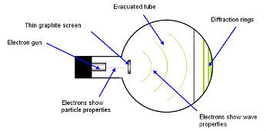

Electron beam tube

[https://spark.iop.org/collections/wave-particle-duality]

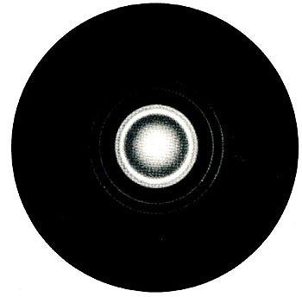

The **diffraction pattern** is in the form of rings. These are caused by the electrons diffracting and interfering as they pass through the regular crystal structure of the graphite. The electrons are behaving like waves and the graphite’s crystal structure acts as a *diffraction grating.*

[https://spark.iop.org/collections/model-atom]

**The de Broglie equation**

In 1923 French physicist Louis de Broglie proposed that a particle of momentum *p* would have a wavelength *λ* given by the equation:

* wavelength of particle ***λ*  = *h/p***
* where *h* is the Planck constant, and p is the momentum of the particle
* or *λ* = *h/mv* for a particle of momentum *mv*, where m is its mass and v is its velocity

The formula allows us to calculate the wavelength associated with a moving particle.

NB The momentum, p, of a moving object is equal to its mass multiplied by its velocity p = mv