**U3a Physics: Atomic and Nuclear Physics**

**Session 8**

**Wave Particle Duality**

**Electron Diffraction**

We know that light can be diffracted. Surprisingly, electrons show the same behaviour! When a beam of electrons is directed onto a double slit, a diffraction pattern is seen, similar to that obtained when light is diffracted. However, a thin sheet of graphite is usually used as the diffracting medium for electrons. The electrons are diffracted around individual crystals and a pattern of rings is observed.

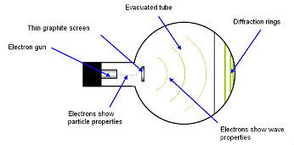

Electron beam tube

[https://spark.iop.org/collections/wave-particle-duality]

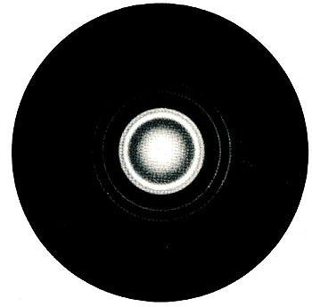

The **diffraction pattern** is in the form of rings. These are caused by the electrons diffracting and interfering as they pass through the regular crystal structure of the graphite. The electrons are behaving like waves and the graphite’s crystal structure acts as a *diffraction grating.*

[https://spark.iop.org/collections/model-atom]

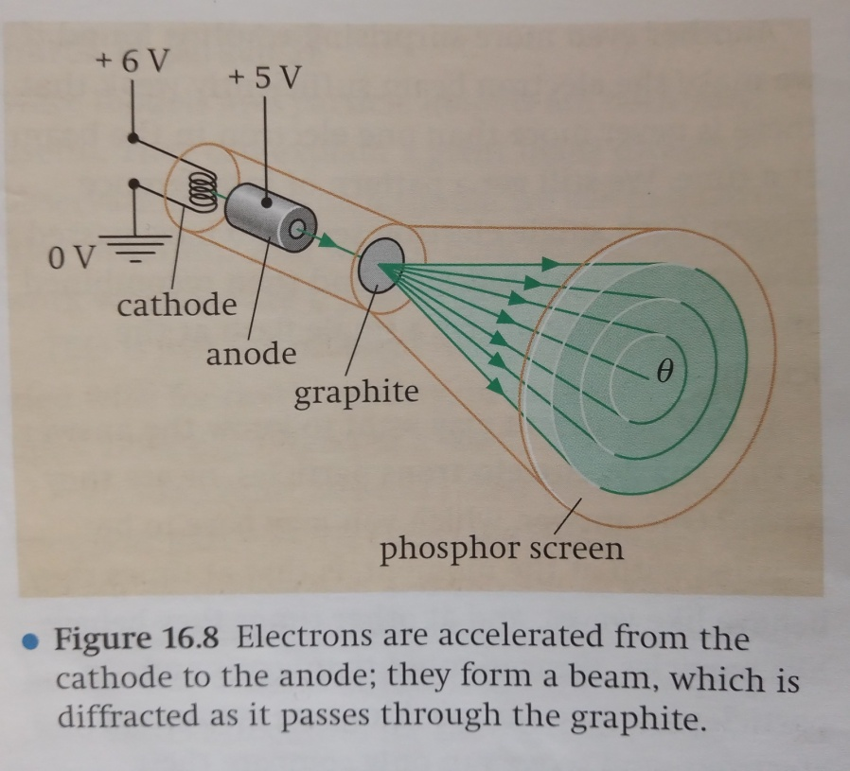

Details of the electron gun

[From “Physics 1” by Sang, Gibbs and Hutchings]

**Electron Waves**

Electrons are particles, we can measure their mass and charge. We use the ides of them being particles to explain electric current, for example. So, it is a surprise to discover that there are situations in which they appear to behave like waves.

**Double slit experiment re-visited (Young’s Slits)**: We have learnt that an interference pattern is seen when light is shone through a double slit. A similar interference fringe pattern appears when electrons are directed towards a double slit: The pattern is seen on a screen coated with phosphor, which produces a flash of light whenever an electron strikes it:

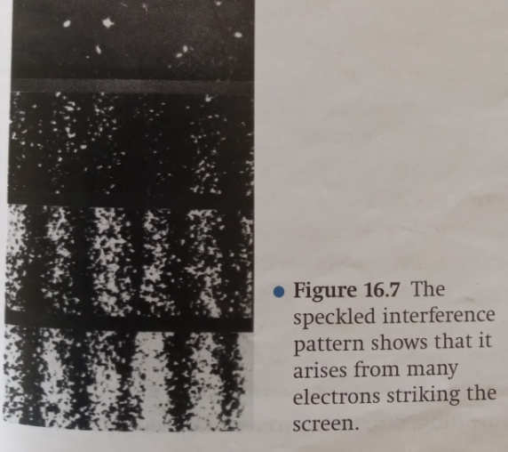

Electron interference pattern

[From “Physics 1” by Sang, Gibbs and Hutchings]

Measurements can be made of the fringes and from that a wavelength can be calculated, This experiment appears to show that the electrons have travelled as waves. However, the fringe pattern is built up from individual dots of light on the screen, so at this point we are observing particles.

It seems that the electrons leave the gun as particles, pass through the slits as waves, and arrive at the screen as particles!

**Another surprise**: If the beam is so weak that there is never more than 1 electron in the beam at a time, we still observe the interference pattern!

Each single electron seems to have passed as a wave through both slits.

Are electrons waves, or are they particles?... At times they behave like waves, at times they behave like particles.

* They behave like waves when they pass through slits
* They behave like particles when they interact with matter (eg when they arrive at the screen)

**Light: waves or particles?**

In order to explain the photoelectric effect, we must use the idea of light as particles, but to explain diffraction, interference and polarisation, we must use the wave model.

Like electrons, light sometimes behaves as a wave, sometimes as particles.

**The de Broglie equation**

In 1924 French physicist Louis de Broglie proposed that, just as light has a dual nature, so do all particles. He proposed that a particle of momentum *p* would have a wavelength *λ* given by the equation:

* wavelength of particle ***λ*  = *h/p***
* where *h* is the Planck constant, and p is the momentum of the particle
* or *λ* = *h/mv* for a particle of momentum *mv*, where m is its mass and *v* is its velocity

The formula allows us to calculate the wavelength associated with a moving particle.

(The momentum, *p*, of a moving object is equal to its mass multiplied by its velocity, so *p* = *mv*)