**U3a Everyday Physics**

**Session 5: Turning forces and levers part 2**

**Three classes of levers**

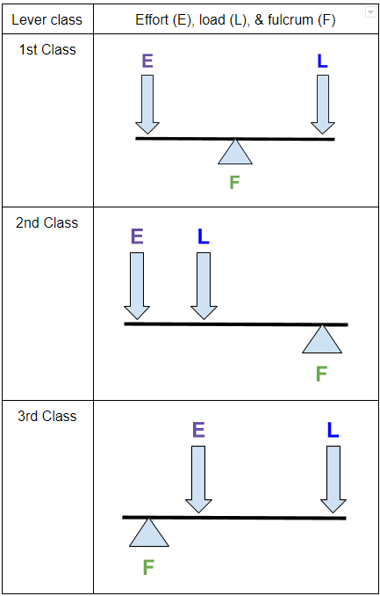

**[visiblebody.com/biomechanics-lever-systems-in-the-body]**

**First class lever examples**

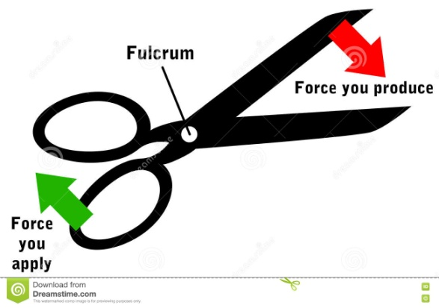

**Effort Fulcrum Load**

Other examples of first class levers are **pliers, a crow bar, a claw hammer, a see-saw and a weighing balance**..

**Second class lever examples**

applied
0.6 m
force
wheelbarrow
weight
(W)
1.5 m[chegg.com]

**Fulcrum Load Effort**

Other examples of 2nd class levers are: **nutcracker, bottle opener**

**Third class lever examples**

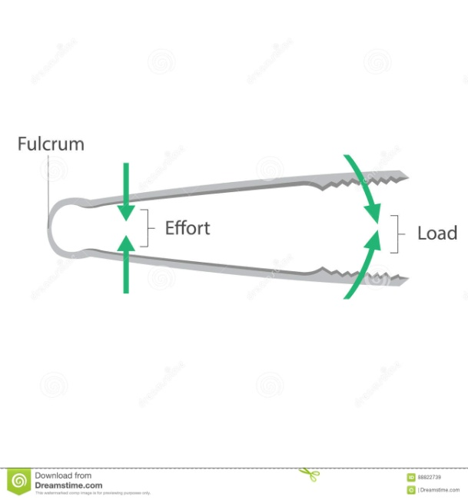

**Fulcrum Effort Load**

Other examples of 3rd class levers: **tweezers, broom, fishing rod**

**The Lever as a machine**

A machine is designed to enable a small force to produce a large force, or to allow a force acting at one point to produce a force acting at another point. A lever is a very simple machine which helps us to do work more easily.

Example: you can use a relatively small force to move a large weight using a crowbar. In this case the crowbar is acting as a ***force magnifier***.

Sometimes a lever acts as a ***distance multiplier***. A distance multiplier moves a load through a large distance but requires a short effort distance. 3rd class levers are common distance multipliers:

E.g. Fishing rods and hockey sticks. When you make a cast, the end of the fishing rod moves more than a metre as your wrist flicks and hardly moves at all.

The input force is known as the **Effort, E**

The output force is the **Load, L**.

The **mechanical advantage, MA**, of the machine is the load divided by the effort.

**MA = L/E**

Second class levers have the best mechanical advantage: they can move a large load with a relatively small effort.

**Torque**

The diagram below shows the forces needed to turn a car’s steering wheel. The forces balance (up and down) so the wheel doesn’t move up, down or sideways. However, it isn’t in equilibrium as the pair of forces cause it to rotate. A pair of forces like this is known as a **couple**.

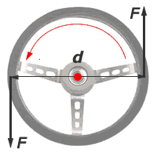 [splung.com physics]

To form a couple, two forces must be:

* Equal in magnitude
* Parallel but opposite in direction
* Separated by a distance, d.

The turning effect, or moment, of a couple is known as its **torque**.

Torque = the sum of the moments of the forces about the centre of the wheel

= F x d/2 + F x d/2 = Fd

Examples of a torque in everyday life:

* Unscrewing a bottle top
* Turning a tap
* Using a screwdriver
* When a cyclist pedals, his or her feet are parallel. One foot pushes a petal forward while the other pushes the other pedal backward.

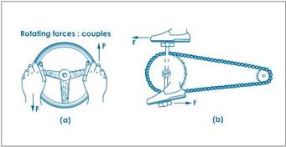 [torquenitup.weebly.com]