**U3a Physics: Everyday Physics**

**Electricity (1): Static electricity**

**Reminder of the structure of an atom**

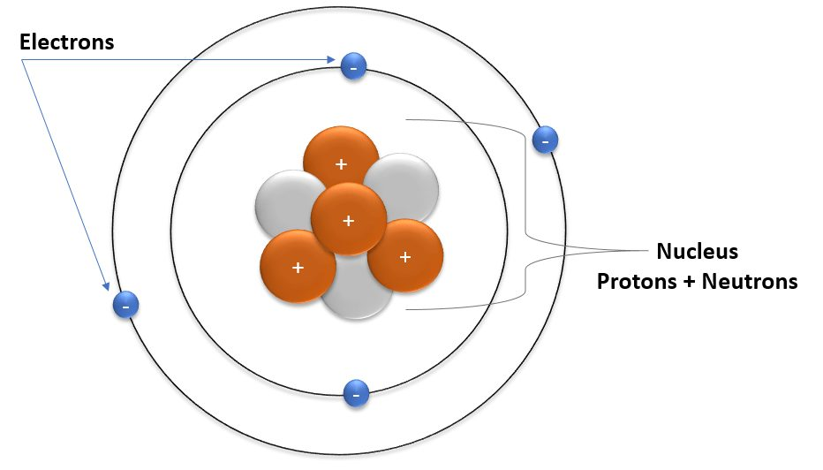

The further from the nucleus the electrons, the less strongly they are bound to the atom and the easier they can become free of the atom.

They can be rubbed off one material onto another (see below).

{Remember: Unlike charges attract, like charges repel one another}

**Charging by friction**

When insulating materials rub against each other, they may become electrically charged. Electrons, which are negatively charged, may be ‘rubbed off’ one material and on to the other. The material that gains electrons becomes negatively charged. The material that loses electrons is left with a positive charge.

**A charged balloon** can stick to a wall, attract a drink can, or deflect a stream of water, even though only the balloon has been electrically charged.

* when the balloon, is moved close to a neutral object, for example a wall, the electrons in the wall are repelled and move further away from the balloon
* this leaves an area of net positive charge on the surface of the wall, even though it is electrically neutral overall

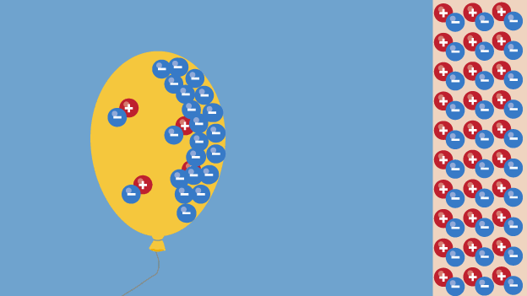

The balloon is charged but the wall is neutral, so they do not attract when far apart.

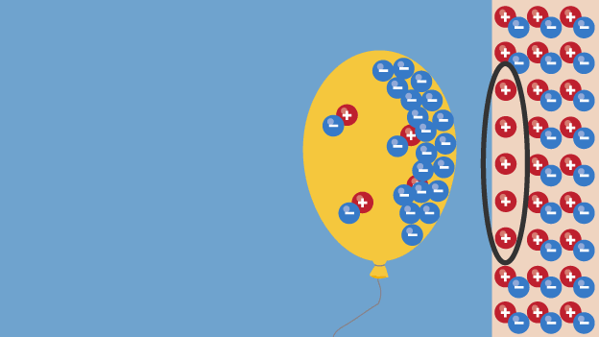

When the balloon is moved close to the wall, some of the electrons in the wall are repelled leaving a region of net positive charge on the wall

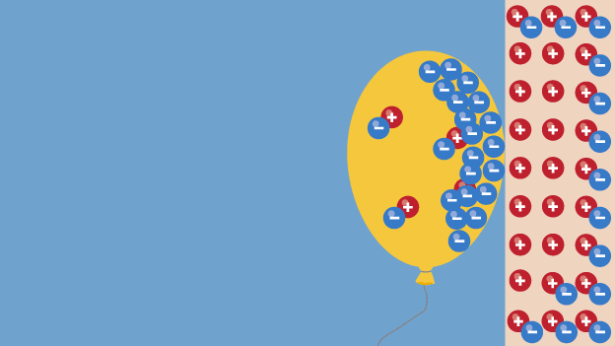

The charged balloon is attracted to the wall

[credit: bbc bitesize]

**Van de Graaff generator**

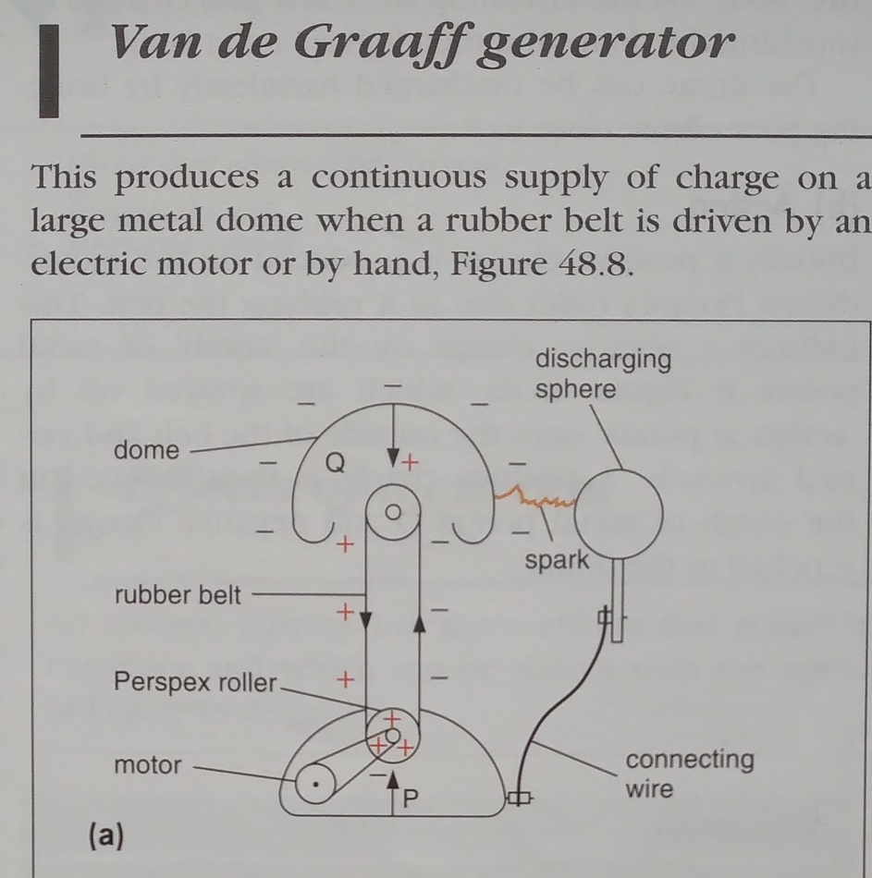

[diag from GCSE Physics by Tom Duncan]

A negative charge builds up on the dome..

A person insulated from the ground and touching the dome of the generator will also gain electrons and become negatively charged. The same will happen to each of their hairs. Since the person, their head and each of their hair follicles are all negatively charged, the hairs will repel from the head and from every other strand causing them to stick out from the head in all directions.

Click on this link to see a video clip explaining how the generator works:

<https://www.youtube.com/watch?v=laDmuQFmK3Y>

**Thunderstorms**

1. Thunderstorms start inside a **cloud**.
2. Bits of ice **move** and **bump into each other** inside the cloud.
3. This builds up an **electric charge**.
4. If the charge builds up enough it can suddenly flow as a massive **electrical current** between the cloud and the ground, or between clouds. We see this as a really **big spark** and it's what we call **lightning**.
5. When lightning happens, it **heats the air** to around **10,000°C**.
6. The air heats up so quickly that it suddenly **expands** creating a **shock wave**, a huge vibration in the air, that we hear as **thunder**.

[bbc bitesize]

**Ball lightning** - This is a very rare and unusual type of lightning (but has been witnessed by Dennis!). It is lightning in the form of a glowing electric ball.

According to Wikipedia**:**: Ball lightning is a rare and unexplained phenomenon, Scientists have proposed a number of hypotheses to explain reports of ball lightning over the centuries, but scientific data remain **scarce.**

**Dangers** **of electrostatics**

All charged objects can be discharged by being earthed. This may happen safely by connecting them to the earth with a conductor.

If the charge is very large, a spark to the earth may happen unexpectedly. Sparks like this can be dangerous, potentially igniting a fire. A build-up of static charge is a potential danger when refuelling aircraft or vehicles. Fuel running through the pipes can provide the friction needed to create a static charge. To prevent this, aircraft are earthed with a conductor during re-fuelling.

Less dangerous, but sometimes painful, a spark discharge may happen if a charged person touches an earthed conductor. For example, a person dragging their feet across the carpet may become charged. If they then reach out to touch a door handle or another person, there is a spark and they feel a small shock.

[bbc bitesize]