**U3a Everyday Physics: Theory of Flight**

**Revision: Balanced and unbalanced forces (examples)**

. 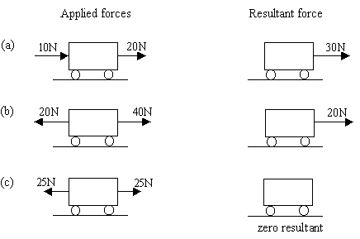

Balanced forces

Unbalanced forces

Unbalanced forces

**Revision: Newton’s Laws**

**Newton’s 1st law of motion**: An object remains in the same state of motion unless a resultant (unbalanced) force acts on it.

So, without a resultant force acting on it, a stationary object would remain stationary...

... and a moving object would continue to move at the same velocity (i.e. at the same speed and in the same direction) unless a resultant force acts on it.

**Newton’s 2nd law of motion**: A resultant force acting on an object will cause the object to accelerate

Resultant force = mass x acceleration

**F = ma**

Units: **F** is in newtons (N) if **m** is in kilograms (kg) and **a** in metres per second squared (m/s2 or ms-2)

So, a resultant force, F, applied to an object of mass, m, will cause it to accelerate.

If F= 0, then a = 0 and if the object is travelling at a speed ,v, it will continue to move at that speed For as long as no external forces act on it.

**The four forces acting on a plane**

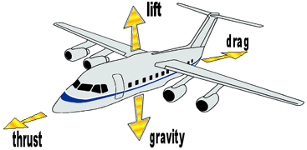[diagram credit: NASA]

**Lift** – upward  
**Drag** - backward  
**Weight** - downward  
**Thrust** - forward

**/Weight**

* If the lift force is greater than the weight of the plane, it will rise
* If the thrust (from the engines) is greater than the drag (air resistance), the plane will accelerate in a forwards direction.
* If Thrust = Drag, there is no resultant horizontal force acting on the plane and it will continue to travel at the same speed, neither accelerating nor slowing down.

**What causes Lift?**

It is the force known as *lift* which keeps the plane in the air. A wing lifts when the pressure above it is lower than the pressure below.

The cross-sectional shape of a wing is an aerofoil:

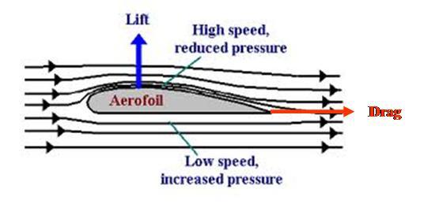

[credit https://www.skybrary.aero/articles/aerofoil]

The curvature of the aerofoil causes the streamlines above it to become curved. The air flow over the top of the wing is faster than that below. This reduces the pressure above the wing:

**The Bernoulli Principle**: The speed of a fluid (eg air) determines the amount of pressure that the fluid can exert. The faster the fluid flows, the lower the pressure it exerts.

**Note about pressure:** Pressure, P, is defined as force acting per unit area, so P = F/A

The SI unit of pressure is the pascal, Pa

The pressure exerted by a fluid (liquid or gas) is exerted equally in all directions. It increases with depth. For example, the pressure at the sea bed is greater than the pressure just a metre or so below the surface of the sea.

**Bernoulli’s Equation**

For a flow of fluid of density,ρ, moving at a height, H, and at a speed, v, the following equation holds:

P + ½ ρv2 + ρgH = constant where g is acceleration due to gravity

For a fluid (of constant density), travelling at a constant height and moving horizontally, ρgH is a constant, so the equation becomes:

P + ½ ρv2 = constant

We can see from this equation that if v increases, then, in order for the left hand side of the equation to remain constant, P must decrease.

So Bernoulli’s equation predicts that the pressure in a faster moving air stream is lower than in a slower moving air stream, which explains the phenomenon of lift.

Go to this website to see a video clip of an aerofoil in an airstream

<https://www.cam.ac.uk/research/news/how-wings-really-work>

Go to this link for more information on Flight:

<https://www.grc.nasa.gov/www/k-12/UEET/StudentSite/dynamicsofflight.html#:~:text=Airplane%20wings%20are%20shaped%20to,wing%20up%20into%20the%20air>.