**Lever Systems in the Body**

**First class lever: nodding your head**

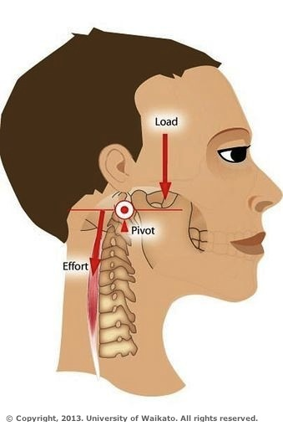 [sciencelearn.org.nz]

**Second class lever: standing on tip-toe**

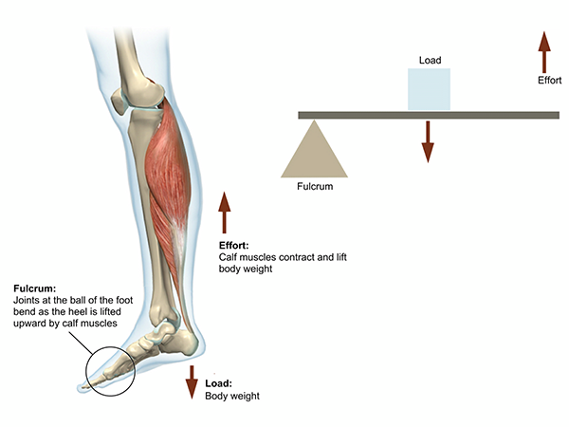

[visiblebody,com]

**Third class lever: biceps curl**

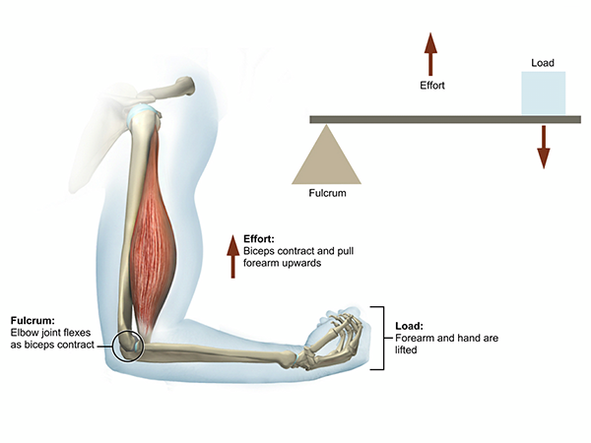

[visiblebody,com]

**First class lever: triceps extension**

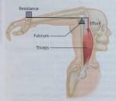

[cotswold.gloucs.sch.uk]