**U3a Physics: The physics of everyday things**

**The Physics of Music (part 1)**

**Some Wave Theory Revision**

A wave transfers energy from one point to another and, as it is propagated through (travels through) a medium, it causes the particles of the medium to vibrate.

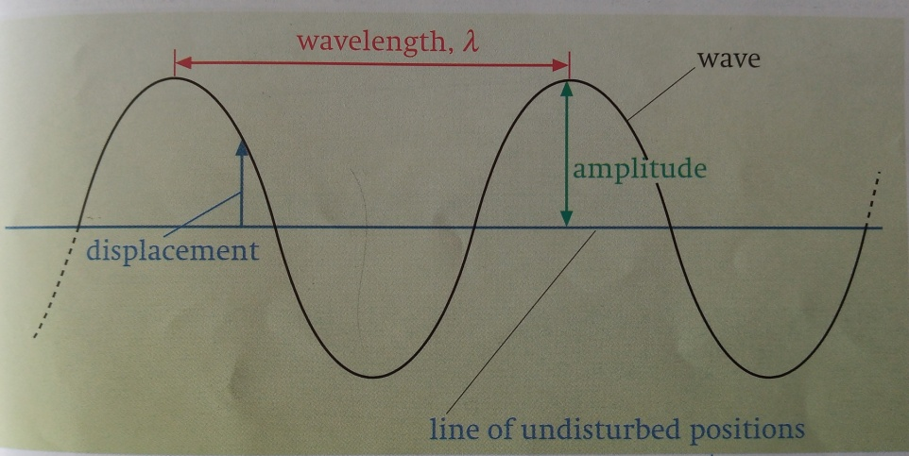

[Credit: Physics 1 by Sang, Gibbs and Hutchings]

The diagram above shows a graphical way of representing a wave. A wave of this particular shape is known as a sine wave.

The distance from any point on the wave to the next similar point (eg peak to peak) is the **wavelength, λ**.

The distance of a point on the wave from its undisturbed (middle) position is its **displacement** and the maximum displacement is the **amplitude**, **a**, of the wave.

The time taken for one complete wave to pass a given point is the **period**, **T**, of the wave. It is measured in seconds.

The number of waves passing a given point in 1second is the **frequency**, **f** (or **ν)**. Frequency is measured in hertz (Hz) where 1 Hz is one wave per second (1 cycle per second).

It can be shown that: wave speed = frequency x wavelength

**v = f λ**

**Sound waves**

Sound waves are **longitudinal waves**. They cause particles to vibrate parallel to the direction of wave travel. The vibrations can travel through solids, liquids or gases. The speed of sound depends on the medium through which it is travelling. When travelling through air, the speed of sound is about 330 metres per second (m/s). Sound cannot travel through a vacuum because there are no particles to carry the vibrations.

## Properties of sound

The frequency of a sound wave is related to the pitch that is heard:

* high frequency sound waves are high pitched
* low frequency sound waves are low pitched

The amplitude of a sound wave is related to the volume of the sound:

* high amplitude sound waves are loud
* low amplitude sound waves are quiet

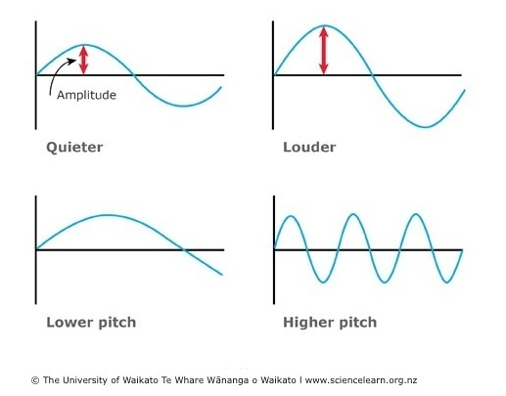

**Stringed instruments** (eg guitar, violin, cello)

Musical instruments create sounds at their natural frequencies, called the harmonics of the instrument. A string fixed at both ends can oscillate in many modes, called harmonics. Some of these harmonics are shown in the diagram below.

( L = length of the string)

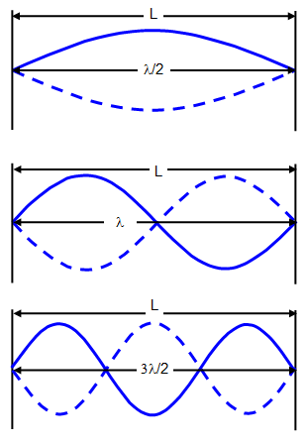 [credit schoolphysics.co.uk]

The frequency , f, of the wave depends on the material of the string (it’s mass per unit volume, μ) and the tension in the string, T. The relationship between these is:

f = 1/ 2L x √(T/μ)

**Brass instruments** (eg trumpet, trombone, tuba)

These are instruments which consist basically of a pipe closed at one end and open at the other end. Causing the air to vibrate at the open end sets up standing (stationary) waves inside the pipe.

Here are the first four harmonics in a pipe closed at one end:

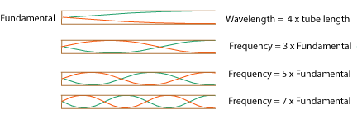

[diagram from cnx.org]

**Other kinds of instruments include;**

* Organs: these have pipes which can be open or closed
* Reed instruments (eg saxophone, clarinet, oboe). The reed vibrates at one end of the pipe, causing the air inside to vibrate. According to Britannica.com:

**reed instrument**, in [music](https://www.britannica.com/art/music), any of several wind instruments that sound when the player’s breath or air from a wind chamber causes a reed (a thin blade of cane or metal) to vibrate, thereby setting up a sound wave in an enclosed air column (in reed pipes) or in the open air.

* Percussion (tuned or not) eg drum, xylophone, triangle
* Keyboard (eg piano, organ, accordion), some have strings, some have reeds. A piano, for example, has strings which are hit by a hammer to produce the notes. According to Britannica.com:

The term reed organ normally refers to a keyboard instrument in which sound is produced by [free reeds](https://www.britannica.com/art/free-reed). Accordions and concertinas are examples of small, hand-held reed organs.

* The **theremin**: a weird instrument which is an electronic instrument with 2 aerials, one which controls pitch, the other controls frequency. It is surrounded by an electric field and is controlled by the player moving their hands in the field, but not actually touching the instrument itself. It is named after its inventor, Leon Theremin, who patented the device in 1928. See <https://en.wikipedia.org/wiki/Theremin> for more details.