**U3a Physics: The physics of everyday things**

**The physics of cooking 1**

Cooking food requires heat energy (thermal energy) to be transferred from a source of heat to the food itself. Before we embark on a study of heat transfer, we need to consider the structure of matter: of solids, liquids and gases.

**The structure of matter: the particle model**

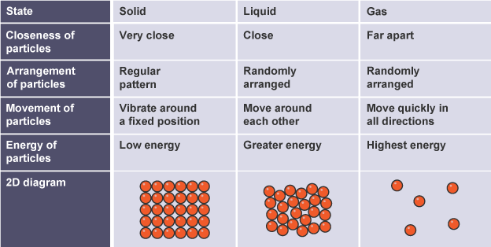

The particles in the diagrams could be atoms, molecules or ions depending on the type of substance. [bbc bitesize]

**The structure of metals**

Apart from mercury, metals are solid at room temperature and have a regular structure as shown above.. However, the outer electrons of metal atoms are not strongly bound and are free to move within the structure of the metal. This means that the metal consists of a lattice of positive ions, surrounded by a sea of free electrons. These electrons are able to move within the structure. 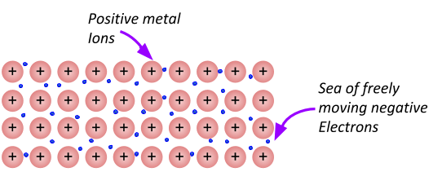

[diag from studyrocket.co.uk]

**Temperature and heat**

Temperature and heat are not the same thing

When a substance is heated, the particles gain energy (kinetic energy) and move faster and over greater distances. The thermal energy (from the heat source) has been converted into kinetic energy of the particles. When the average energy of the particles in a substance is increased, its temperature increases.

The increase in temperature of an object depends on its mass and the material from which it is made (more on this later).

**Thermometers**

There are several different kinds of thermometer, but the sort most familiar to us is a glass one containing a liquid (mercury, alcohol..) The liquid expands as it warms and moves up the inner tube,

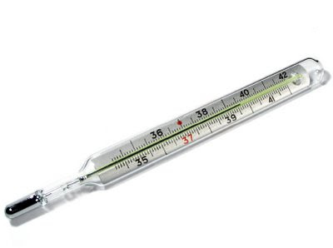 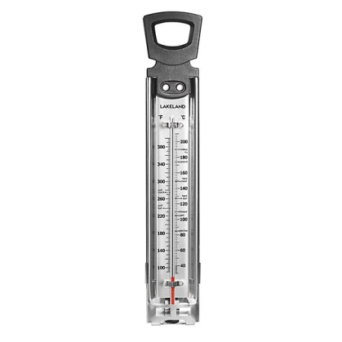

The right-hand picture shows a sugar thermometer, used in jam making. It is calibrated with both Celsius and Fahrenheit scales.

A sugar thermometer's long, narrow shape allows you to safely check the temperature of hot sugar or hot oil without burning yourself. It is long enough to comfortably sit in a pan of boiling liquid.

Most sugar thermometers can measure temperatures as high as 400°F (approx 200°C), or higher.

### Temperature Scales (taken from physicsclassroom.com)

The thermometer calibration process described above results in what is known as a **centigrade thermometer**. A centigrade thermometer has 100 divisions or intervals between the normal freezing point and the normal boiling point of water. Today, the centigrade scale is known as the **Celsius scale**, named after the Swedish astronomer Anders Celsius who is credited with its development. The Celsius scale is the most widely accepted temperature scale used throughout the world. It is the standard unit of temperature measurement in nearly all countries, the most notable exception being the United States. Using this scale, a temperature of 28 degrees Celsius is abbreviated as 28°C.

Traditionally slow to adopt the metric system and other accepted units of measurements, the United States more commonly uses the **Fahrenheit temperature scale**. A thermometer can be calibrated using the Fahrenheit scale in a similar manner as was described above. The difference is that the normal freezing point of water is designated as 32 degrees and the normal boiling point of water is designated as 212 degrees in the Fahrenheit scale. As such, there are 180 divisions or intervals between these two temperatures when using the Fahrenheit scale. The Fahrenheit scale is named in honor of German physicist Daniel Fahrenheit. A temperature of 76 degree Fahrenheit is abbreviated as 76°F. In most countries throughout the world, the Fahrenheit scale has been replaced by the use of the Celsius scale.

Temperatures expressed by the Fahrenheit scale can be converted to the Celsius scale equivalent using the equation below:

**°C = (°F - 32°) x 5/9**

Similarly, temperatures expressed by the Celsius scale can be converted to the Fahrenheit scale equivalent using the equation below:

**°F= °Cx9/5 + 32°**

These two temperature scales are the ones that you will come across in recipe books and on electric cookers.

The **Kelvin scale** is the absolute temperature scale that is commonly used in science. The SI temperature unit is the **kelvin**, which is abbreviated K (not accompanied by a degree sign).

0 K is **absolute zero**. The freezing and boiling points of water are 273.15 K and 373.15 K, respectively. Note that a change in temperature of 1K is equal to that of 1°C.