WARNING

CHECK THAT THE CORRECT DATABASE IS IN USE.
1 STANDARD INFORMATION 4
2 Client Form 8
2.1 Summary 8
Tool Bar B 9
Client Summary Bar 9
2.2 Interactions Tab 11
2.3 Submissions Tab 13
2.3.1 Maintain Submissions 15
2.3.2 Maintain Submission Status 17
2.4 Maintain Interactions 18
2.4.1 Interaction Form 18
2.4.1.1 Filter Interactions 18
2.4.1.2 Interaction Tab 20
2.4.1.3 Interaction Form – Activity Tab 22
2.4.2 Lookup Client (Add Group Session Icon) 24
2.4.2.1 Find Clients - Group Session 26
2.4.2.2 Interaction Form – Group Session 28
2.4.2.3 Add Attendee to Group Session 30
2.5 Activities 32
2.5.1 Simple Generic Activity (Issue Bus Token - 1) 32
2.5.2 Simple Generic Activity (Issue Bus Token - 2) 34
2.5.3 Add to Active Register 36
2.5.4 Create Call Back 37
2.5.5 Create CAP 38
2.5.6 Create Future Interaction 39
2.5.7 Endorse Client 41
2.5.8 New BA Claim 42
2.5.9 Issue Learning Card 43
2.5.10 Join Guarantee 44
2.5.11 Leave Guarantee 46
2.5.12 Create Mail Merge 48
2.5.13 Remove Endorsement 49
2.5.14 Remove From Registers 50
2.5.15 Running Notes 52
2.5.16 Submit 53
2.5.17 User Defined Actvities 55
55
3 Provider Form 56
3.1 Summary 56
3.2 Interactions Tab 58
3.2.1 Filter Interactions 60
60
4 Opportunity Form 61
4.1 Submissions Form 61
4.1.1 Filter Submissions 63
4.1.2 Maintain Submission 65
4.1.3 Maintain Submission Status 66
5 Common Functionality 67
5.1 Mail Merge 67
5.1.1 Document Template (Type 1) 69
5.1.2 Document Template (2) 70
70
5.1.3 Document Tools 71
5.1.4 Stored Paragraphs (Detail) 72
5.1.5 Stored Paragraphs (Access) 73
5.1.6 Import Document 74
5.1.7 Maintain Note 75

STANDARD INFORMATION

Screen Header  Minimise  Window  Exit | - Descriptor Ok? (Correct, consistent spelling )  - Bold  - Does it minimise screen?  - Does it create a window  - Does it exit from screen?
Big Icons down left  Headed ‘Careers’ | - Home – Home Page  - Client – Lookup Client Page  - Opportunity – Look up Opportunity Page  - Provider – Lookup Provider Page  - Tasks – Tasks Page  - Reports – Reports Page
Tab Sequence | - If ‘Ok’ highlighted and ‘return’ pressed or single click, should activate screen  - If ‘Cancel’ highlighted and ‘return’ pressed or single click, should activate screen  - Is order of moving from one thing to the next okay?
Buttons | - ‘Ok’ Should activate screen  - ‘Cancel’ Cancels screen and closes  - Check that data changes saved/not saved  - ‘Stop’ should stop search
Text boxes | - Is the correct text displayed within the information box (generic)?  - If more than 4 lines of text – up/down arrows become active (more generic)
Standard pull down lists & dynamic  Searching | - Is list ‘open’/’closed’? –  - “Starts with” (etc) = Closed List  - Text box = Open List  - Ability to choose from drop down list if ‘closed’ – validation that typing doesn’t match  - Ability to type in field if ‘open’  - When moving over list from drop down, do categories highlight?  - Chosen category should be put into box if selected  - Lowercase leading capitals (Descriptor)  - Aligned  - Type in first few characters – does search happen  - ‘Date of Birth’ fields which are non mandatory have are activated by tick box or clicking on down arrow to pulldown monthly calender
Drop down menus | - File  - Exit  - Edit  - View  - List  - Cards  - Toolbar  - Status Bar  - Go  - Home  - Lookup Client  - Lookup Opportunity  - Lookup Provider  - Tasks  - Reports  - Actions  - New Client  - New Opportunity  - New Provider  - Tools  - Find Clients  - Find Opportunities  - Find Providers  - Templates and Paragraphs  - System Administration  - Help  - Contents  - Search for help on …  - About Careers …
Tool bar - A | - New Client  - New Opportunity  - New Provider  - Find Clients  - Find Opportunity  - Find Provider  - View as: dropdown – List/Cards
Tool bar – B | - Save and Close  - Close  - Save  - Print  - Delete Client
Record Tabs | - Summary – Information screen  - Interactions – Most 10 recent interactions screen  - Situations – Most recent 10 situations screen  - Subs – Submissions with no outcome  - Quals – Information screen  - Aspirations – Information screen  - Contacts – Information screen  - S/N – Information screen  - General – Information screen  - Other – Information screen  - Docs/Notes – Information screen
Client Summary Bar | - Read only  - Name  - Age  - Goal  - Team  - Situation  - School (if applicable)  - Year (if applicable)  - From (date) (if applicable)  - Time left on Guarantee (if applicable)  - On Active Register (if applicable)  - Alert icon
Date picker | - Ability to type in  - Drop down arrow invokes monthly calendar allowing selection
Tool bar C | - Save and Close  - Close  - Save  - Print  - New Opportunity  - Search Clients  - Delete Provider
Provider Summary Bar | - Read only  - Name  - Contact and Title  - Telephone Number  - Type  - Nature of Business  - Number of Employees
Tool Bar D | - Save and Close  - Close  - Save  - Save as New Opportunity  - Vacancy Card  - Search Clients  - Open Provider  - Mail Merge Provider  - Print  - Delete Opportunity
Opportunity Summary Bar | - Title  - Provider  - Places left  - Type  - Contact  - Status
Find Now | - Does it? Performance. Test with Ann’s data and procedures
New Search | - Should clear selection boxes and previous search results. Test with Ann’s data and procedures
Tool Bar E | - Save and Close  - Close  - Save  - Print  - New Opportunity  - Search Clients  - Delete Provider
Record Tabs  Opportunity | - Display  - Subs  - Summary  - General  - Monitoring  - Emp/Trg/HE/FE/Ed  - Address  - H&S  - Docs/Notes
Record Tabs  Provider | - Summary  - Details  - Contacts  - EBP  - Doc/Notes  - Provider LMI  - Employment LMI  - H&S  - Interactions  - Opps

Client Form

Summary

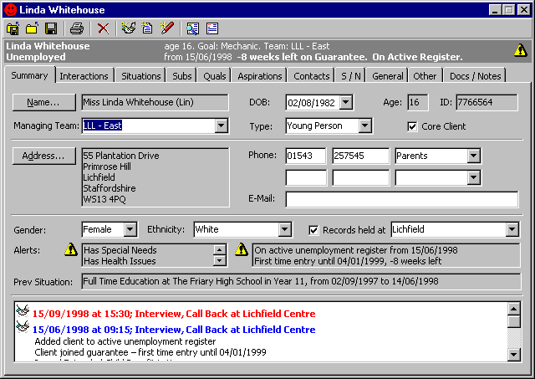

Field/ Data  Header | - Expected Behaviour | Ok  √ | Non/Compliance/Other Remarks
HEADER
Screen Header  . Bold  . Minimise  . Exit | - Standard Information  - Standard  - Standard Information  - Standard Information
FIELD
Managing Team | - Pulldown defaults to that of the user  - Closed list |  | MANDATORY
Date of Birth | - Date Picker  - Standard Information |  | MANDATORY
Age | - Default (read only)
ID | - Created by System (read only)
Type | - Pulldown defaults to blank box  - Closed list |  | MANDATORY
Core Client | - Check box
2 phone sections | - Ability to type in 2 separate boxes  - Pulldown defaults to blank  - Open list
E-Mail | - Ability to type in |  | Double clicking should invoke e-mail software with “to:” = client e-mail address
Gender | - Pulldown  - Closed list |  | MANDATORY
Ethnicity | - Pulldown  - Closed list |  | MANDATORY
Records held at | - Check box and pulldown  - Closed list
Alerts | - Information Icon displays text when selected  - Alert box Up/Down arrows active
Previous Situation | - Read only text
Interaction Summary | - Last 2 interactions displayed  - Scroll bar arrows active and working |  | Next release
Tab sequence | - Does it go to next logical field?
BUTTONS
Name | - Full name screen
Address | - Address screen
Record Tabs | - Standard Information  - Are they invoked when selected?
Tool Bar B | - Standard Information
Client Summary Bar | - Standard Information

Interactions Tab

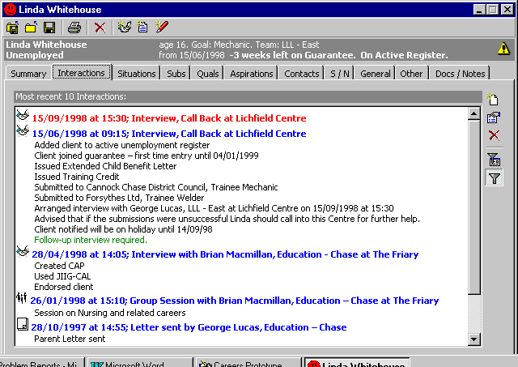

Field/ Data  Header | - Expected Behaviour | Ok  √ | Non/Compliance/Other Remarks
HEADER
Screen Header  Minimise  Exit | - Standard Information
FIELD
Screen | - Screen information shows most recent 10 Interactions by default
BUTTONS
Right Hand Screen Icons
Add Interaction | - Invokes “Interaction” screen with Interaction and Activities Tabs
Change Interaction | - As above – Add Interaction
Delete Interaction | - Deletes highlighted interaction
Define Filter | - Invokes “Filter Interactions” screen
Apply Filter | - Changes Summary Bar to “All Interactions”
Record Tabs | - Are they invoked when selected?

Submissions Tab

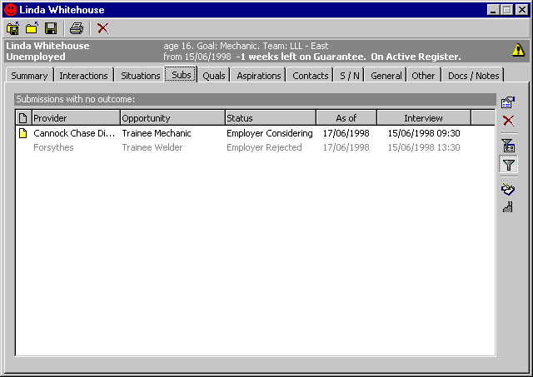

Field/ Data  Header | - Expected Behaviour | Ok  √ | Non/Compliance/Other Remarks
HEADER
Screen Header  Minimise  Exit | - Standard Information
FIELD
Submissions Tab | - Screen shows:  - Provider  - Opportunity  - Status  - As Of  - Interview
BUTTONS
Change Submission | - Invokes Status History for highlighted submission
Delete Submission | - Deletes highlighted submission
Define Filter | - Invokes “Filter Submissions” screen
Apply Filter | - Shows “All Submissions”
Open Opportunity | - Opens Opportunity at “Display” tab
Open Provider | - Opens Provider at “Summary” tab
Record Tabs | - Are they invoked when selected?

Maintain Submissions

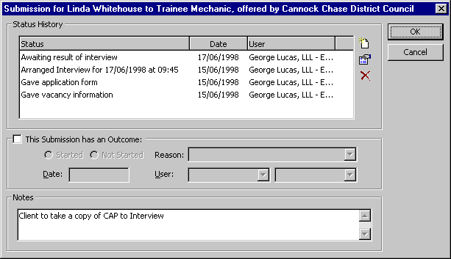

Field/ Data  Header | - Expected Behaviour | Ok  √ | Non/Compliance/Other Remarks
HEADER
Screen Header  Exit | - Standard Information
FIELD
Status History | - Shows:  - Status  - Date  - User
This Submission has an Outcome | - Check box blank initially with all other fields “greyed out”  - Once check box ticked, all other fields become “active” and blank.
Reason | - Pulldown – closed list
Date | - Pulldown – closed list
User | - Name and Team Pulldown – closed lists
Notes | - Ability to type information free-text
Tab Sequence | - Does it go to next logical field?
BUTTONS
Add Status | - Invokes “Submission Status” screen
Change Status | - Invokes “Submission Status” screen
Delete | - Deletes highlighted submission
Radio Buttons | - Initially blank, ability to click on and off
Ok | - Standard Information
Cancel | - Standard Information

Maintain Submission Status

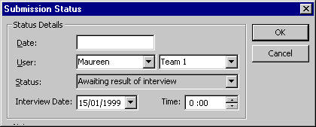

Field/ Data  Header | - Expected Behaviour | Ok  √ | Non/Compliance/Other Remarks
HEADER
Screen Header  Exit | - Standard Information
FIELD
Status Details  Date | - Dropdown calendar – ability to type
User | - 2 Parts – Name and Team, both pulldown – Closed lists
Status | - Pulldown, dynamic search?
Interview Date | - Dropdown calendar – ability to type
Time | - Default – 00:00. Up/Down arrows to set time. Ability to type in figures
Tab Sequence | - Does it go to next logical field?
BUTTONS
Ok | - Standard Information
Cancel | - Standard Information

Maintain Interactions

Interaction Form

Filter Interactions

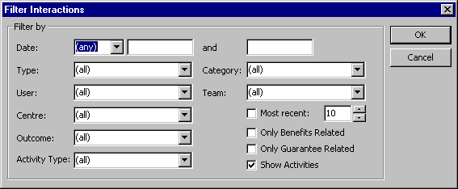

Field/ Data  Header | - Expected Behaviour | Ok  √ | Non/Compliance/Other Remarks
HEADER
Screen header  Exit | - Standard Information  - Standard Information
FIELD
Date | - Pulldown Closed List  - 2 – Boxes with Date Pickers and ability to type
Type | - Defaults to (all) Pulldown Closed List with dynamic search
Category | - Defaults to (all) Pulldown Closed List with dynamic search
User | - Defaults to (all) Pulldown Closed List with dynamic search
Team | - Defaults to (all) Pulldown Closed List with dynamic search
Centre | - Defaults to (all) Pulldown Closed List with dynamic search
Outcome | - Defaults to (all) Pulldown Closed List with dynamic search
Activity Type | - Defaults to (all) Pulldown Closed List with dynamic search
Most Recent | - Tick Box
Number Box | - Defaults to 10 can use up/down arrows to adjust numbers
Only Benefit Related | - Tick Box
Only Guarantee Related | - Tick Box
Show Activities | - Tick Box
BUTTONS
OK  Cancel | - Standard Information

Interaction Tab

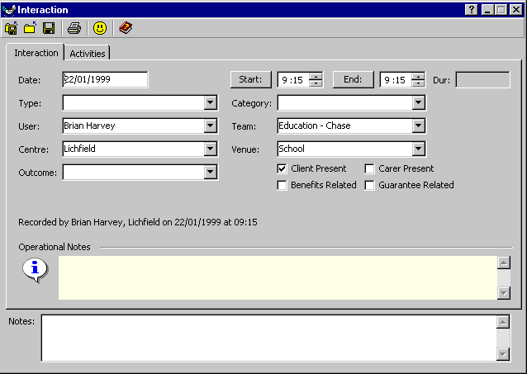

Field/ Data  Header | - Expected Behaviour | Ok  √ | Non/Compliance/Other Remarks
HEADER
Screen Header  Minimise  Help  Exit | - Standard Information
FIELD
Date | - Defaults to Current, Date Picker, ability to type
Start | - Defaults to Current, Up/Down arrows, ability to type
End | - Defaults to Current, Up/Down arrows, ability to type
Dur | - Read only, system use
Type | - Blank initially, pulldown menu – closed list
Category | - Blank initially, pulldown menu – closed list
User | - Defaults to current user, pulldown menu – closed list
Team | - Defaults to current user, pulldown menu – closed list
Centre | - Defaults to that of current user |  | Needs to be clarified
Venue | - Defaults to that of Team |  | Needs to be clarified
Outcome | - Blank initially, dropdown list
Tab Sequence | - Does it go to next logical field?
BUTTONS
Record Tabs | - Are they invoked when selected?

Interaction Form – Activity Tab

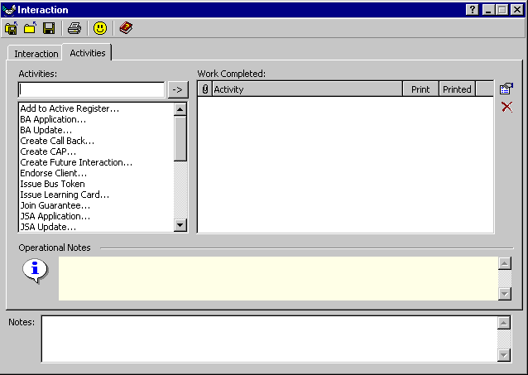

Field/ Data  Header | - Expected Behaviour | Ok  √ | Non/Compliance/Other Remarks
HEADER
Screen Header  Minimise  Help  Exit | - Standard Information
FIELD
Activities | - Blank Initially, categories listed in box. Up/Down Arrows active
Work Completed | - Blank Initially
Headings | - Attached Forms
 | - Activity
 | - Print
 | - Printed
Operational Notes | - Information. Read only
Notes | - Ability for user to type information
Tab Sequence | - Does it go to next logical field?
BUTTONS
Change Activity | - Inactive unless activity in ‘Work Completed’ highlighted
Delete Activity | - Deletes highlighted activity in ‘Work Completed’
Tool Bar B | - Standard Information

Lookup Client (Add Group Session Icon)

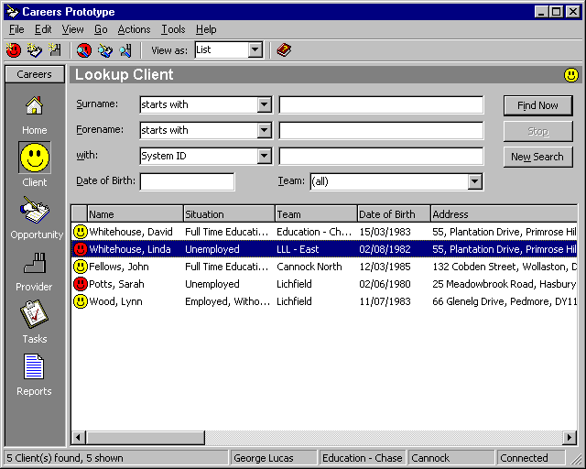

Field/ Data  Header | - Expected Behaviour | Ok  √ | Non/Compliance/Other Remarks
HEADER
Screen Header  . Bold  . Minimise  . Window  . Exit | - Standard Information  - Standard  - Standard Information  - Standard Information  - Standard Information
FIELD
Surname | - Pulldown – 2 parts – Closed and Open
Forename | - Pulldown – as above
With | - Pulldown – as above
Date of Birth | - Date Picker – Standard Information |  | Checkbox – when ticked datebox & dropdown calendar
Team | - Pulldown – defaults to (all)  - Closed list
Tab sequence | - Does it go to next logical field?
BUTTONS
Tool bar A | - Standard Information
Menu bar | - Standard Information
Find Now  New Search | - Standard Information  - Standard Information

Find Clients - Group Session

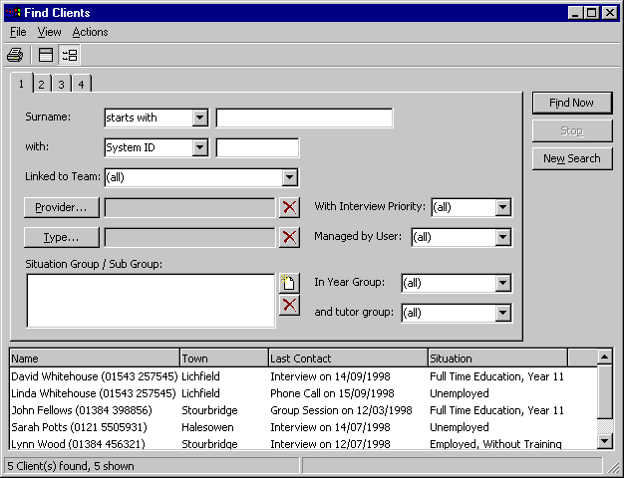

Field/ Data  Header | - Expected Behaviour | Ok  √ | Non/Compliance/Other Remarks
HEADER
Screen Header  Minimise  Exit | - Standard Information
FIELD
Surname | - 1st box – ‘Starts With’ –pulldown closed list  - 2nd box – ability to type
With | - 1st box – ‘System ID’ – pulldown closed list  - 2nd box – ability to type
Linked to Team | - Defaults to ‘(all)’ – pulldown closed list
With Interview Priority | - Defaults to ‘(all)’ – pulldown closed list
Managed by User | - Defaults to ‘(all)’ – pulldown closed list
In Year Group | - Defaults to ‘(all)’ pulldown closed list
And tutor Group | - Defaults to (all)’ pulldown closed list
Tab Sequence | - Does it go to next logical field?
BUTTONS
Provider | - Invokes ‘Lookup Provider’ screen
Delete Provider | - Deletes Provider
Type | - Invokes ‘Client Type’ screen
Delete Type | - Deletes Type
Add Situation/Sub Group | - Invokes ‘Situation Sub Group’ screen
Delete Situation/Sub Group | - Deletes Situation/Sub Group
Find Now | - Returns list at bottom of screen with the following headings:  - Name  - Town  - Last Contact  - Situation
New Search | - Clears screen
Toolbar D | - Standard Information
Dropdown Menu B | - Standard Information
Record Tabs | - Are they invoked when selected?

Interaction Form – Group Session

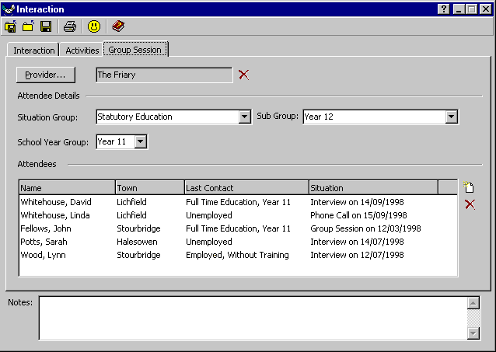

Field/ Data  Header | - Expected Behaviour | Ok  √ | Non/Compliance/Other Remarks
HEADER
Screen Header  Minimise  Help  Exit | - Standard Information
FIELD
Attendee Details  Situation Group | - Pulldown – closed
Sub Group | - Pulldown – closed
School Year Group | - Pulldown – closed
Attendees | - Listed in box with following headings:-  - Name  - Town  - Last Contact  - Situation
Tabbing Sequence | - Does it go to next logical field?
BUTTONS
Provider | - ‘Lookup Provider for Group Session’ screen invoked
Delete Provider | - Deletes Provider
Add Client | - ‘Add Client to Group Session’ screen invoked
Delete Client | - Deletes highlighted client
Record Tabs | - Are they invoked when selected?
Toolbar B | - Standard Information

Add Attendee to Group Session

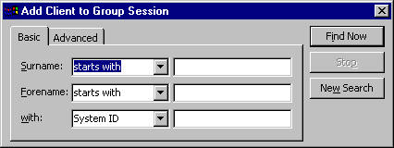

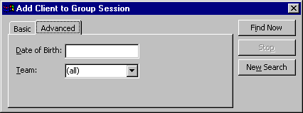

Field/ Data  Header | - Expected Behaviour | Ok  √ | Non/Compliance/Other Remarks
HEADER
Screen Header  Exit | - Standard Information
FIELD
Basic Tab-
Surname | - Pulldown Closed List, defaults to ‘starts with’  - Ability to Type
Forename | - Pulldown Closed List, defaults to ‘starts with’  - Ability to Type
With | - Pulldown Closed List, defaults to System ID  - Ability to Type
Advanced Tab-
Date of Birth | - Default to 16years of age  - Standard Information
Team | - Defaults to (All)  - Pulldown Closed List
BUTTONS
Find Now | - Standard Information
Stop | - Standard Information
New Search | - Standard |Information

Activities

Simple Generic Activity (Issue Bus Token - 1)

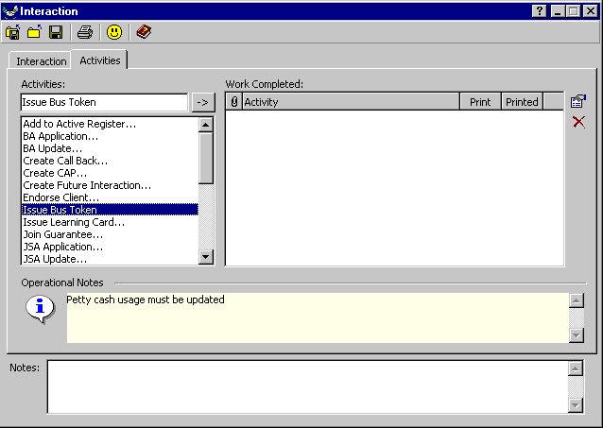

Field/ Data  Header | - Expected Behaviour | Ok  √ | Non/Compliance/Other Remarks
HEADER
Screen Header  Minimise  Help  Exit | - Standard Information
FIELD
Click on ‘Issue Bus Token’ | - Title appears in ‘Activities’ box
Operational Notes | - Information relevant to activity
Notes | - Ability for user to type notes
BUTTONS
Record Tabs | - Are they invoked when selected?
Toolbar B | - Standard Information

Simple Generic Activity (Issue Bus Token - 2)

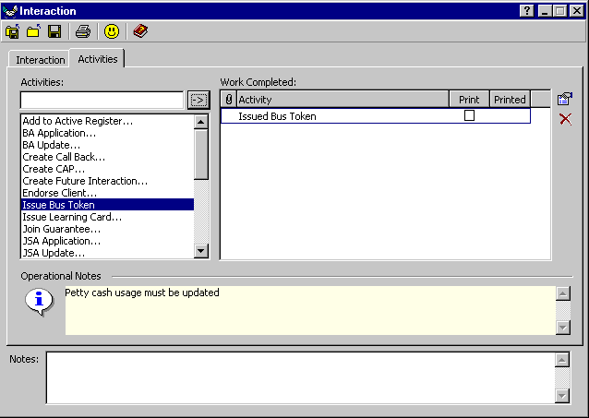

Field/ Data  Header | - Expected Behaviour | Ok  √ | Non/Compliance/Other Remarks
HEADER
Screen Header  Minimise  Help  Exit | - Standard Information
FIELD
Double click on Activity | - E.g. Issue Bus Token – Activity title copied to ‘Work Completed’ box
Single click on Activity  Then click on DS field arrow | - Activity title copied to ‘Activities’ box  - Activity title copied to ‘Activities’ box
Operational Notes | - Information relevant to activity
Notes | - Ability for user to type notes
BUTTONS
Change Activity | - ?
Delete Activity | - Deletes highlighted activity
Record Tabs | - Are they invoked when selected?
Toolbar B | - Standard Information

Add to Active Register

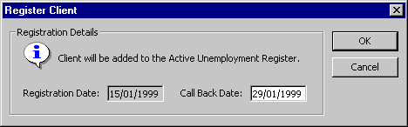

Field/ Data  Header | - Expected Behaviour | Ok  √ | Non/Compliance/Other Remarks
HEADER
Screen Header  Exit | - Standard Information
FIELD
Registration Details | - Relevant Information displayed.  - Default – current date- greyed out
Call Back Date | - Default – 2 weeks hence, dropdown calendar, ability to type
Information | - Relevant to Activity
Tabbing Sequence | - Does it go to next logical field?
BUTTONS
Ok | - Standard Information
Cancel | - Standard Information

Create Call Back

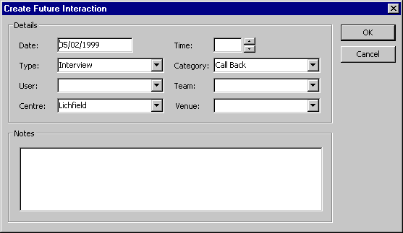

Field/ Data  Header | - Expected Behaviour | Ok  √ | Non/Compliance/Other Remarks
HEADER
Screen Header  Exit | - Standard Information
FIELD
Date | - Default 2 weeks’ hence. Pulldown calendar
Time | - Abiltiy to type. Increase/decrease arrows
Type | - Pulldown. Closed list
Category | - Pulldown. Closed list
User | - Pulldown. Closed list
Centre | - Pulldown. Closed list
Venue | - Pulldown. Closed list
Notes | - Ability for user to type notes.
Tabbing Sequence | - Does it go to next logical field?
BUTTONS
Ok | - Standard Information
Cancel | - Standard Information

Create CAP

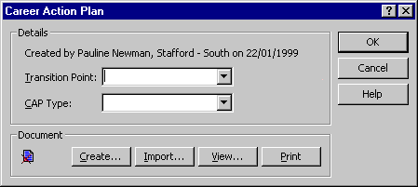

Field/ Data  Header | - Expected Behaviour | Ok  √ | Non/Compliance/Other Remarks
HEADER
Screen Header  Help  Exit | - Standard Information
FIELD
Transition Point | - Pulldown - Closed list
CAP Type | - Pulldown – Closed list
Tabbing Sequence | - Does it go to next logical field?
BUTTONS
Create | - Invokes ‘Document Template’
Import
View
Print
Ok | - Standard Information
Cancel | - Standard Information
Help | - Standard Information

Create Future Interaction

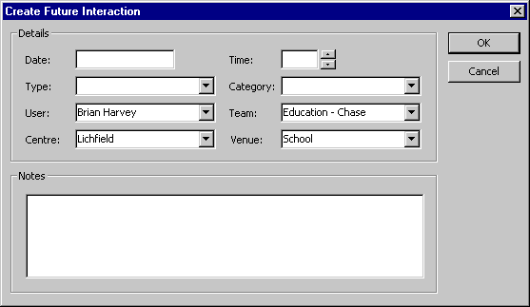

Field/ Data  Header | Expected Behaviour | Ok  √ | Non/Compliance/Other Remarks
HEADER
Screen Header  Exit | - Standard Information
FIELD
Date | - Date picker, pulldown calendar, ability to type
Time | - Ability to type – increase/decrease arrows
Type | - Pulldown – Closed list
Category | - Pulldown – closed list
User | - Defaults to current user, pulldown – closed list.
Team | - Defaults to that of current user, pulldown – closed list
Centre | - Defaults to that of current user, pulldown – closed list
Venue | - Default (?) pulldown – closed list
Notes | - Ability for user to type notes
Tabbing Sequence | - Does it go to next logical field?
BUTTONS
Ok | - Standard Information
Cancel | - Standard Information

Endorse Client

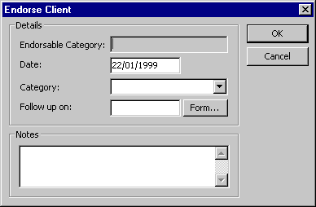

Field/ Data  Header | Expected Behaviour | Ok  √ | Non/Compliance/Other Remarks
HEADER
Screen Header  Exit | - Standard Information
FIELD
Endorsable Category | - Read Only
Date | - Dropdown calendar, ability to type
Category | - Pulldown – closed list
Follow up on | - Dropdown calendar, ability to type
Notes | - Ability for user to type notes
Tabbing Sequence | - Does it go to next logical field?
BUTTONS
Form
Ok | - Standard Information
Cancel | - Standard Information

New BA Claim

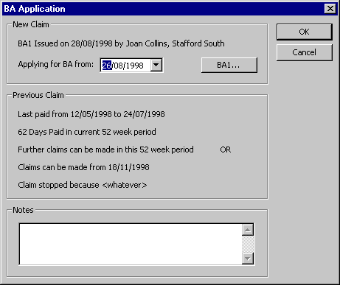

Field/ Data  Header | Expected Behaviour | Ok  √ | Non/Compliance/Other Remarks
HEADER
Screen Header  Exit | - Standard Information
FIELD
Applying for BA From | - Dropdown calendar, ability to type
Previous Claim | - Read Only
Notes | - Ability for user to type notes
BUTTONS
BA1
Ok | - Standard Information
Cancel | - Standard Information

Issue Learning Card

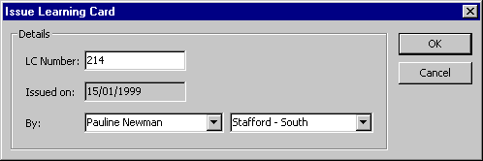

Field/ Data  Header | Expected Behaviour | Ok  √ | Non/Compliance/Other Remarks
HEADER
Screen Header  Exit | - Standard Information
FIELD
LC Number | - Ability to type in number.
Issued on | - Read Only. Default to current date
By | - Default to User - closed list  - Default to User Team, pulldown, closed list
Tabbing Sequence | - Does it go to next logical field
BUTTONS
Ok | - Standard Information
Cancel | - Standard Information

Join Guarantee

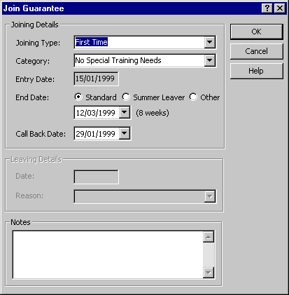

Field/ Data  Header | Expected Behaviour | Ok  √ | Non/Compliance/Other Remarks
HEADER
Screen Header  Exit | - Standard Information
FIELD
Joining Type | - Pulldown – closed list
Category | - Pulldown – closed list
Entry Date | - Read only. Defaults to current date
End Date | - Radio Buttons –  - Standard  - Summer Leaver  - Other
 | - Dropdown Calendar – ability to type
 | - Default – 8 weeks’ hence
Call back date | - 2 weeks’ hence
Leaving Details | - Greyed out
Notes | - Ability for user to type notes
Tabbing Sequence | - Does it go to next logical field?
BUTTONS
Ok | - Standard Information
Cancel | - Standard Information
Help | - Standard Inforamtion

Leave Guarantee

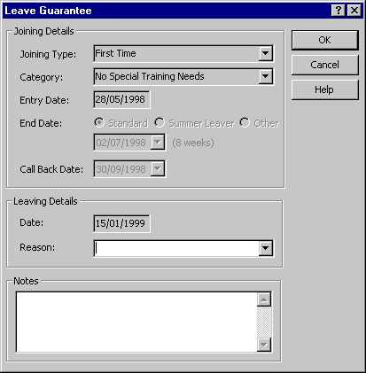

Field/ Data  Header | Expected Behaviour | Ok  √ | Non/Compliance/Other Remarks
HEADER
Screen Header  Help  Exit | - Standard Information
FIELD
Joining Type | - Read only
Category | - Read only
Entry Date | - Read only
End Date | - Greyed out
Call Back Date | - Greyed out
Leaving Details  Date | - Read Only, default to current date
Reason | - Puldown list
Notes | - Ability for user to type notes
Tabbing Sequence | - Does it go to next logical field?
BUTTONS
Ok | - Standard Information
Cancel | - Standard Information
Help | - Standard Information

Create Mail Merge

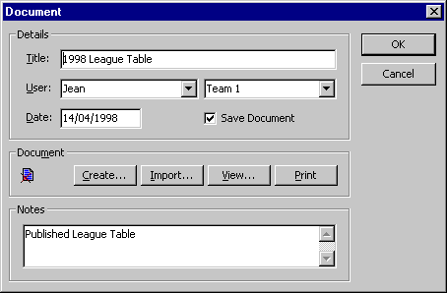

See Common Functionality

Remove Endorsement

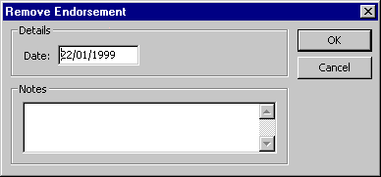

Field/ Data  Header | - Expected Behaviour | Ok  √ | Non/Compliance/Other Remarks
HEADER
Screen Header  Exit | - Standard Information
FIELD
Date | - Date Picker – ability to type
Notes | - Text box, ability for user to type notes
Tabbing Sequence | - Does it go to next logical field?
BUTTONS
Ok | - Standard Information
Cancel | - Standard Information

Remove From Registers

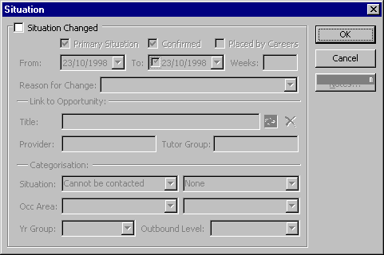

Field/ Data  Header | - Expected Behaviour | Ok  √ | Non/Compliance/Other Remarks
HEADER
Screen Header  Exit | - Standard Information
FIELD
Situation Changed | - Check Box – Initially blank and rest of screen greyed out.  - Once Check Box ticked rest of screen becomes active
Primary Situation | - Check box – ticked by default
Confirmed | - Check box – ticked by default
Placed by Careers | - Check box – blank by default
From | - Completed by default – dropdown calendar
To | - Check box – dropdown calendar
Weeks | - Read only – completed by default
Reason for Change | - Pulldown – closed list
Title | - Read Only
Provider | - Read only
Tutor Group | - Text box, ability to type
Situation | - 2 boxes – pulldown open lists(?)
Occ Area | - 2 boxes – pulldown – closed list
Year Group | - Pulldown – closed list
Outbound Level | - Pulldown – closed list
BUTTONS
Search Opportunities | - Invokes ‘Find Opportunities’ screen
Remove Link to Opportunity | - Deletes
Ok | - Standard Information
Cancel | - Standard Information
Notes | - Invokes ‘Notes’ Screen

Running Notes

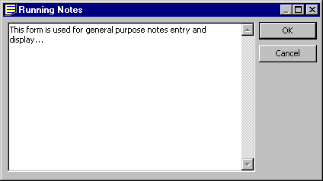

Field/ Data  Header | - Expected Behaviour | Ok  √ | Non/Compliance/Other Remarks
HEADER
Screen Header  Minimise  Maximise  Exit | - Standard Information
FIELD
Screen | - Ability to Type- scroll up/down active when text box full
BUTTONS
OK  Cancel | - Standard Information

Submit (Temporary facility)

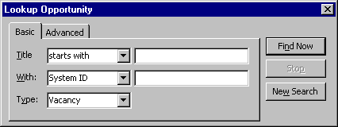

Field/ Data  Header | - Expected Behaviour | Ok  √ | Non/Compliance/Other Remarks
HEADER
Screen Header  Exit | - Standard Information
FIELD
Basic Tab:  Title | - Closed Pulldown List, defaults to ‘starts with’  - Text Box with ability to type
With | - Closed Pulldown List defaults to ‘system ID’  - Text Box with ability to type
Type | - Closed Pulldown List defaults to vacancy
Advanced Tab:  Provider | - Greyed out by default
Geog | - Closed Pulldown List defaults to ‘All’
Status | - Closed Pulldown List defaults to ‘Live’
BUTTONS
Provider | - Activated ‘Lookup Provider’
Find Now | - Standard Information
Stop | - Standard Information
New Search | - Standard Information

User Defined Actvities

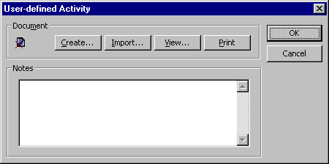

Field/ Data  Header | - Expected Behaviour | Ok  √ | Non/Compliance/Other Remarks
HEADER
Screen Header  Exit | - Standard Information
FIELD
Document:
Create | - Invokes ‘Document Template’ –Type 1
Import | - Invokes ‘’Import Document’
View
Print
Notes | - Ability to type  - Scroll bars activates when screen full
BUTTONS
OK  Cancel | - Standard Information

.

Provider Form

Summary

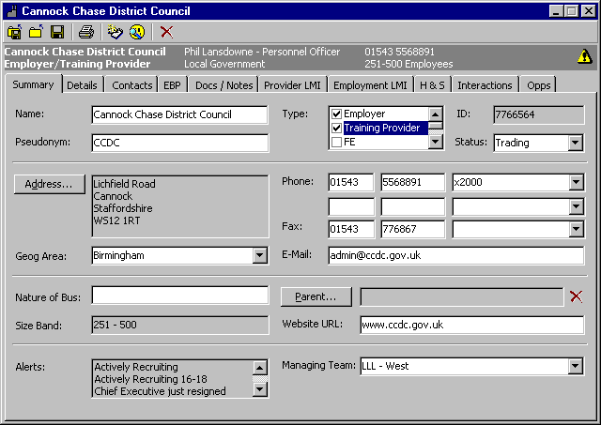

Field/ Data  Header | - Expected Behaviour | Ok  √ | Non/Compliance/Other Remarks
HEADER
Screen Header  . Bold  . Minimise  . Exit | - Standard Information  - Standard  - Standard Information  - Standard Information
FIELD
Name | - Ability to type in text
Pseudonym | - Ability to type in text
Type | - Check boxes –  - Employer, Training Provider, FE, HE, Parent, School  - Up/Down Arrows
ID | - Created by system  - Read only
Status | - Pulldown  - Closed list
Geog Area | - Pulldown  - Closed list
Phone (2 Sections) | - Ability to type number in 2 boxes  - 3rd box for ‘free’ type/ pulldown  - Open list
Fax | - As above “Phone”
E-Mail | - Ability to type in E-Mail Address  - Should load e-mail package on double click
Nature of Business | - Ability to type in information – free text
Size Band | - Read only
Website URL | - Ability to type in website address  - Should load e-mail package on double click
Alerts | - Read only  - Up/Down arrows activated if more than 3
Managing Team | - Pulldown
Tab sequence | - Does it go to next logical field?
BUTTONS
Record Tab | - Standard Information  - Are they invoked when selected?
Tool bar C | - Standard Information
Provider Summary bar | - Standard Information
Address | - Invokes Address panel for completion
Parent | - (Temporarily) loads look-up. Will eventually have its own screen

Interactions Tab

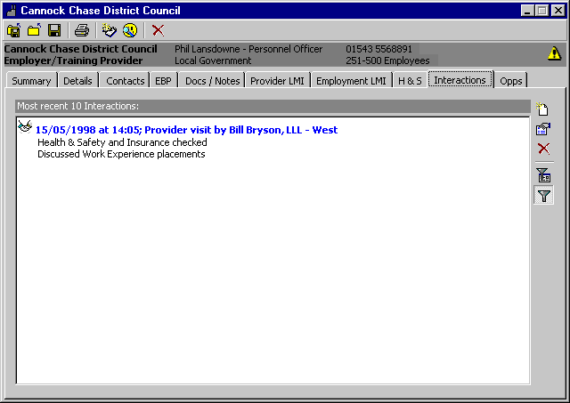

Field/ Data  Header | - Expected Behaviour | Ok  √ | Non/Compliance/Other Remarks
HEADER
Screen header  Minimise  Exit | - Standard Information
FIELD
Screen | - Screen information contains 10 recent interactions
BUTTONS
Right Hand Icons:  Add Interaction | - Invokes ‘Interaction’ Screen with Interaction and Activities Tabs
Change Interaction | - As above
Delete Interaction | - Deletes highlighted Interaction
Define Filter | - Invokes ‘Filter Interaction’ Screen
Apply Filter | - Defaults to 10 most recent Interactions, when filter removed All Interaction shown and Summary Bar changes to ALL.
Tool Bars E | - Standard Information
Provider Summary Bar | - Standard Information

Filter Interactions

See Filter Interactions on Client

Opportunity Form

Submissions Form

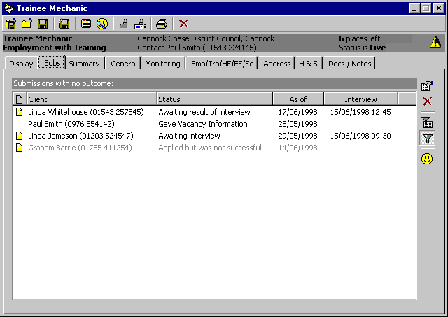

Field/ Data  Header | - Expected Behaviour | Ok  √ | Non/Compliance/Other Remarks
HEADER
Screen Header  Minimise  Exit | - Standard Information
FIELD
Submissions Tab | - Screen Shows – Submissions with no outcome.  - Client  - Status  - As of  - Interview
BUTTONS
Right Hand Icon  Change Submission | - Invokes ‘Submission’ Screen for highlighted submission
Delete Submission | - Deletes highlighted submission
Define Filter | - Invokes ’Filter Submission’
Apply Filter | - Defaults to ‘Submission with no outcome’  - If depressed and filter taken off, gives ALL submissions
Open Client | - Opens Client highlighted on submission list
Tool Bar | - Standard Information Tool Bar D
Summary Bar | - Standard Information (Opportunity Summary Bar)
Record Tabs | - Standard Information (Opportunity)

Filter Submissions

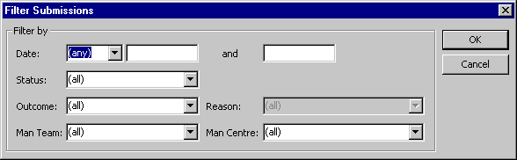

Field/ Data  Header | - Expected Behaviour | Ok  √ | Non/Compliance/Other Remarks
HEADER
Screen header  Exit | - Standard Information
FIELD
Date | - Defaults to ‘any’, pulldown closed list  - 2 date boxes with dropdown date pickers and the ability to type (depending on pulldown option selected.  - Any-Box 1open 2 greyed out  - Since-Box 1 open 2 greyed out  - Up to – Box 1 greyed out 2 open  - Between – Box 1 & 2 open
Status | - Default to (all), pulldown closed list
Outcome | - Defaults to (all) pulldown closed list
Man Centre | - Defaults to (all) pulldown closed list
Reason | - Greyed out
Man Team | - Default to (all) pulldown closed list
Tab Sequence | - Does it go to next logical field?
BUTTONS
OK | - Standard Information
Cancel | - Standard Information

Maintain Submission

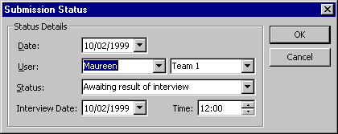

Field/ Data  Header | - Expected Behaviour | Ok  √ | Non/Compliance/Other Remarks
HEADER
Screen Header  Exit | - Standard Information
FIELD
Status Details:  Date | - Defaults to today’ date, dropdown date picker and ability to type
User | - 2 parts – Defaults to Current User & Team  - Pulldown closed list
Status | - Pulldown, closed list , dynamic search
Interview Date | - Default to today’s date Dropdown date picker and ability to type
Time | - Default to 12:00 up/down arrows to set time, will need to use mouse or right arrow key to move to minutes. Ability to type.
Tab Sequence | - Does it go to next logical field?
BUTTONS
OK | - Standard Information
Cancel | - Standard Information

Maintain Submission Status

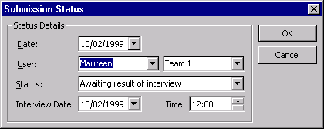

Field/ Data  Header | - Expected Behaviour | Ok  √ | Non/Compliance/Other Remarks
HEADER
Screen Header  Exit | - Standard Information
FIELD
Status Details:  Date | - Defaults to today’ date, dropdown date picker and ability to type.
User | - 2 parts – Defaults to Current User & Team  - Pulldown closed list.
Status | - Greyed out.
Interview Date | - Default to today’s date Dropdown date picker and ability to type
Time | - Default to 12:00 up/down arrows to set time, will need to use mouse or right arrow key to move to minutes. Ability to type.
Tab Sequence | - Does it go to next logical field?
BUTTONS
OK | - Standard Information
Cancel | - Standard Information

Common Functionality

Mail Merge

- 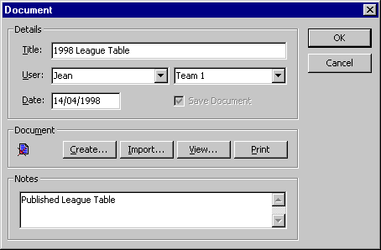

Field/ Data  Header | - Expected Behaviour | Ok  √ | Non/Compliance/Other Remarks
HEADER
Screen Header  Exit | - Standard Information
FIELD
Title | - Text box – ability to type
User | - 2 boxes – Name, pulldown closed list. Team – pulldown closed list.
Date | - Dropdown calendar – ability to type
Save Document | - Check box
Notes | - Text box, ability for user to type notes
Tabbing Sequence | - Does it go to next logical field?
BUTTONS
Create | - Invokes ‘Document Template’ –Type 2
Import | - Invokes ‘Import Document’
View
Print
Ok | - Standard Information
Cancel | - Standard Information

Document Template (Type 1)

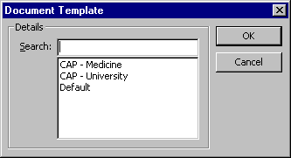

Field/ Data  Header | - Expected Behaviour | Ok  √ | Non/Compliance/Other Remarks
HEADER
Screen Header  Exit | - Standard Information
FIELD
Search | - Choose from list below
BUTTONS
OK  Cancel | - Standard Information

Document Template (2)

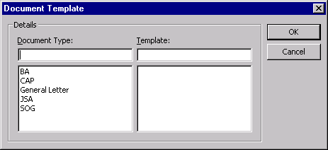

Field/ Data  Header | - Expected Behaviour | Ok  √ | Non/Compliance/Other Remarks
HEADER
Screen header  Exit | - Standard Information
FIELD
Document Type | - Choose from list below, CAP General Letter SOG can use dynamic search
Template | - Choose from list , this will be a default list generated from document type and will be defined by user. Can use dynamic search.
BUTTONS
OK | - Standard Information
Cancel | - Standard Information

Document Tools

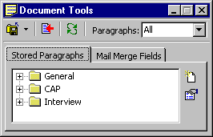

Field/ Data  Header | - Expected Behaviour | Ok  √ | Non/Compliance/Other Remarks
HEADER
Screen Header  Minimise  Maximise  Exit | - Standard Information
FIELD
Paragraphs | - Defaults to All, Closed Pulldown List
Stored Paragraphs Tab | - Add/Change Icons Invoke ‘Stored Paragraphs’
Screen | - List of Files
Mail Merge Tab | - List of Files
BUTTONS
Add/Change Buttons only on Stored Paragraphs Tab | - Invokes ‘Stored Paragraphs’

Stored Paragraphs (Detail)

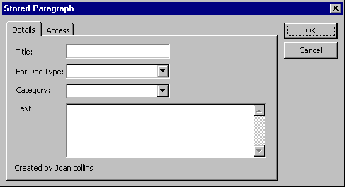

Field/ Data  Header | - Expected Behaviour | Ok  √ | Non/Compliance/Other Remarks
HEADER
Screen Header  Exit | - Standard Information
FIELD
Detail Tab -  Title | - Text Box
For Doc Type | - Pulldown Closed List
Category | - Pulldown Closed List
Text Box | - Ability to type, scroll bars become active when text box full
BUTTONS
OK  Cancel | - Standard Information

Stored Paragraphs (Access)

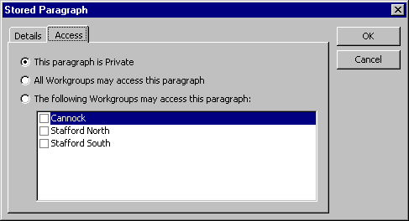

Field/ Data  Header | - Expected Behaviour | Ok  √ | Non/Compliance/Other Remarks
HEADER
Screen Header  Exit | - Standard Information
FIELD
Access Tab-  This paragragh is Private | - Radio Button
All Workgroups may access this paragraph | - Radio Button
The following Workgroups may access this paragraph | - Radio Button
Screen | - Check Boxes alongside Workgroups
BUTTONS
OK  Cancel | - Standard Information

Import Document

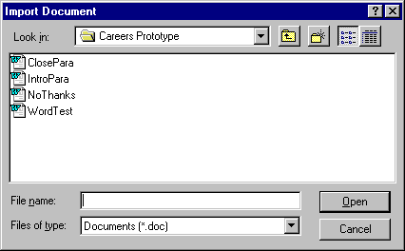

Field/ Data  Header | - Expected Behaviour | Ok  √ | Non/Compliance/Other Remarks
HEADER
Screen Header  ?  Exit | - Standard Information
FIELD
Look in | - Pulldown List of Files
Screen | - List of Documents
File Name | - Ability to type
Files of type | - Pulldown List
BUTTONS
Open | - Opens File
Cancel | - Standard Information

Maintain Note

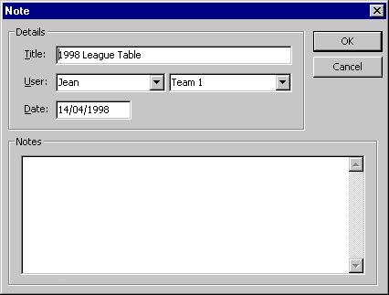

Field/ Data  Header | - Expected Behaviour | Ok  √ | Non/Compliance/Other Remarks
HEADER
Screen header  Exit | - Standard Information
FIELD
Title | - Text Box ability to type.
User | - Default to current use and team.  - Pulldown closed list
Date | - Dropdown date picker, ability to type.
Notes | - Text box with ability to type.
BUTTONS
OK | - Standard Information
Cancel | - Standard Information

