**u3a Physics: Cosmology/Astrophysics**

**General relativity**

Einstein published his General Theory of Relativity in 1915, ten years after his Special Theory, which had taken no account of gravity.

Newton’s gravitational theory had been very successful. His Law of gravitation allows the calculation of the gravitational force, F, between two objects of masses m1 and m2, with their centres a distance r apart:

F = G m1 m2 /r2

G is a constant known as the Universal gravitational constant and has the value

G = 6.67 x 10-11 Nm2/kg2

Einstein wanted to find a way of including gravity in his theory of relativity. His new theory explained everything that Newton had explained, while solving some of its problems. His theory suggested the possibility of the existence of black holes. It also explained the gradual shifting over time of Mercury’s orbit, which Newton’s theory had been unable to do.

**Principle of Equivalence**

This tells us that acceleration and gravity are indistinguishable from one another and therefore equivalent to one another. Einstein came to this conclusion by means of a thought experiment: He imagined 2 spaceships, one stationary on the Earth’s surface and the other accelerating at 9.8 m/s2 through interstellar space. Whatever experiment you carried out in these spaceships (eg just dropping something) would give identical results and there would be no way of telling which ship you were in. Any effects produced by acceleration must also occur due to gravity. An upwards acceleration is exactly equivalent to a downwards gravitational pull.

**Relativity and Time**

As a result of another thought experiment, Einstein came to the conclusion that acceleration, and therefore also gravity, affects time.

A clock at the bottom of a mountain runs more slowly that one at the top (where gravity is less)

Experiment has verified this. In 1960, Robert Pound and Glen Rebka used an atomic clock and discovered that the clock ran more slowly at the bottom of the 23m high Jefferson Tower than at the top.

A clock will run more slowly in the presence of a large mass (like a black hole) than it would on earth.

**Relativity and Space**

The principle of equivalence is important as far as cosmologists are concerned because it implies that gravity causes a beam of light to curve. This is known as Gravitational Lensing and large masses are needed for the effect to be detectable.

Einstein calculated that a beam of light passing very close to the edge of the Sun would be deflected by 1.75 arc seconds ! arc second = 1/3600°). This prediction was confirmed in 1919 by two groups of astronomers who took measurements during a solar eclipse.

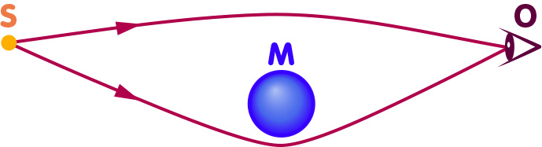

The diagram above shows a [mass](https://www.einstein-online.info/en/explandict/mass/) M which deflects light from a distant light source S in such a way that the light reaches an observer O along two different paths. As a consequence, O will see two distinct images of S:

(<https://www.einstein-online.info/en/spotlight/grav_lensing_history/> )

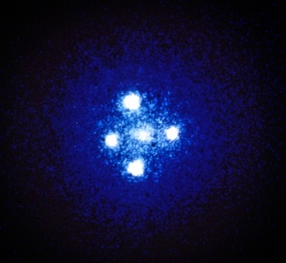

 A galaxy situated between Earth and a quasar 8 billion light-years away creates a “gravitational lens” that bends the quasar’s light, creating the four bright outer objects in this image above. (Credit NASA/ESA/STScI)

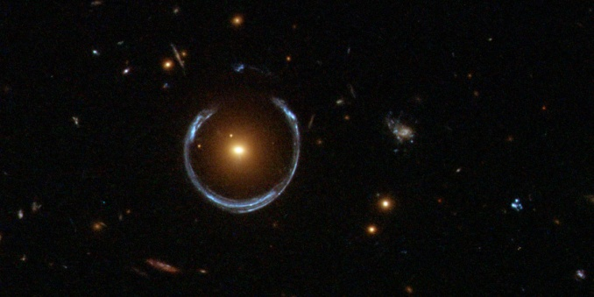

The gravity of a luminous red galaxy (LRG) has gravitationally distorted the light from a much more distant blue galaxy (see diagram above). More typically, such light bending results in two discernible images of the distant galaxy, but here the lens alignment is so precise that the background galaxy is distorted into a horseshoe – a nearly complete ring. (Credit: ESA/Hubble & NASA)

**The modern explanation for the gravitational force** is based on Albert Einstein's general theory of relativity. According to Einstein, Newton's notion that gravity is due to a force that acts instantly, and at a distance, between objects with mass is wrong. There is no gravitational force. Rather, in Einstein's view, the gravitational force is a consequence of the geometry of space and time.

The essential idea is that space is rather like an elastic medium that can be distorted or curved..

So, in the case of the solar system, the Sun causes a significant geometric distortion. A planet moving in this region of distorted (curved) space-time reacts to the distortion by moving differently to the way it would move if the Sun had been absent and the space undistorted. This is why the planets orbit the Sun. (https://spark.iop.org/accounting-gravity )

At its most basic, general relativity is a way to describe gravity by attributing it to the curvature of space-time that occurs in the presence of massive bodies. Massive objects cause space-time to stretch. One way to think about it is to imagine stretching a piece of fabric between a couple of people, and then putting a heavy ball in the middle. The ball will make a dent in the cloth. Then if you roll a small ball across the fabric, it will seem to be attracted to the larger ball, though it’s really just following the dent in the cloth.

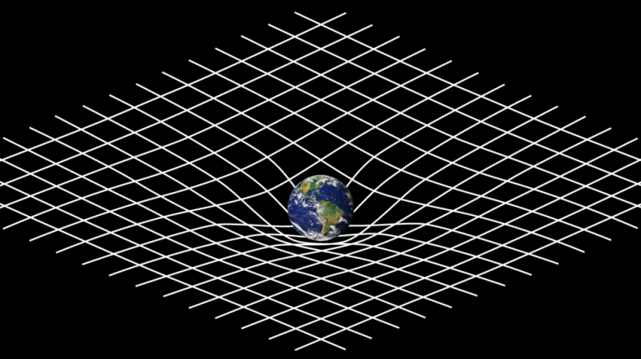 (Credit: NASA)