**Cosmology/Astrophysics**

Session 2: **Early models of the universe**

Cosmology is the study of the structure, origins and future of the universe. It embraces the natural sciences especially physics and astronomy (and maths).

It concerns the physical universe but also Time.

All theories of the universe have been built on the observations that it has been possible to make at the time: i.e. to begin with, using the naked eye but, as time went by, using more and more sophisticated observational instruments and techniques (telescopes of various kinds). The theories were attempts to make sense of the available observations.

Early theories were based on these observations:

* The sun rises in the east and sets in the west
* The sun climbs highest in the sky during summer months
* The stars are in fixed patterns but their positions change during the year
* The moon moves across the sky and changes shape

Nearly all early models of the universe were **Geocentric** (the Earth at the centre and stationary).

**Aristotle** (4th century BC) proposed an earth-centred universe, and this remained the standard model for thousands of years.

The Greeks thought that circles and spheres were “perfect” shapes, so assumed planetary bodies and orbits had these shapes.

**Ptolomaic Model** (2nd century AD)

Geocentric: spherical earth surrounded by a crystalline sphere which supports the stars. The sun moves around this sphere one revolution per year. The movements of the moon and the 5 “wandering stars” (the known planets at the time) were explained by assuming a set of nesting crystalline spheres, one each for the moon and planets.

As more and more accurate observations were made, more and more (complicated) modifications had to be made to the model, which became less and less convincing.

**Copernicus** (1471 - 1543)

Copernicus looked for a more reasonable arrangement of circles and suggested a **Heliocentric** model of the universe (sun at the centre).

This got a hostile reception, partly because his model could not be made to fit the observed positions of the planets exactly.

This problem was resolved by **Kepler** (1571 – 1630), who realised that the orbits of planets are not exact circles but are ellipses, with the sun at one of the foci of the ellipse (now known as Kepler’s 1st Law).

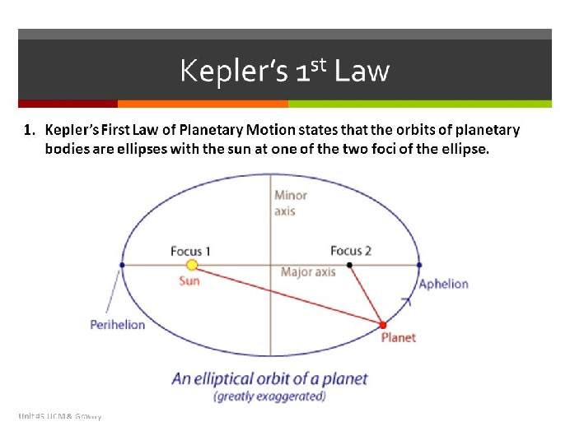

**Galileo** (1564 – 1642)

In 1609 Galileo obtained a (recently invented) telescope, enabling much more accurate observations to be made. He was able to observe planets and their moons.

The work of Galileo and Kepler helped most scientists accept the Copernican (heliocentric) model of the universe. Isaac Newton built on their work and formulated his Law of Gravitation, realising that the same law applied to the fall of an apple to earth and to the motion of planetary bodies.

