**U3a Physics: Cosmology/Astrophysics**

**Observational Astronomy**

Astronomers observe the universe using all parts of the Electromagnetic Spectrum, from Gamma Rays and X-rays through to radio waves. Different kinds of telescopes/observational systems are needed depending on what is being studied. Some are located on the ground (detecting visible light and radio waves), some are on satellites in orbit around the Earth (detecting gamma rays and X-rays as well as visible light and ultraviolet). Others are buried in ice or deep underground in order to try and detect neutrinos and other particles.

**The electromagnetic spectrum**

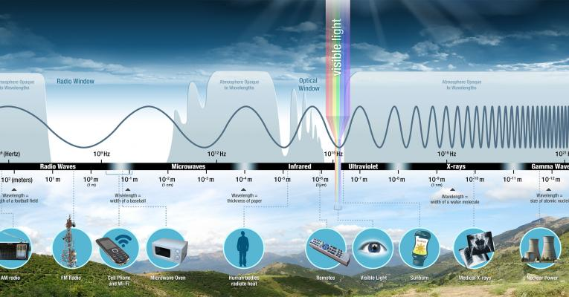

https://science.nasa.gov/ems/01_intro

Early telescopes were optical (observing light) and use lenses but most modern telescopes, and all large ones, use mirrors. Mirrors are lighter than lenses and are easier to shape. Powerful lenses are thicker than less powerful ones and so are heavier.

**Development of optical telescopes**

The construction of the first optical telescope is isually credited to Hans Lipperley, a Dutch spectacle maker (1608). He noticed that if he looked through 2 lenses, one in front of the other, he saw distant objects magnified. Galileo heard of this and designed a telescope for himself, becoming the first person to use a telescope to look at the night sky. He was able to see mountains and craters on the moon’s surface and to investigate the Milky Way.

In 1668 Isaac Newton built the first workable reflecting telescope and in 1789 William Herschel built a large reflecting telescope with a mirror 49 inches in diameter.

**Some important telescopes**

**The Lovell Telescope at Jodrell Bank**

This telescope, which has been operating since 1957, is one of the biggest and most powerful radio telescopes in the world.. Radio waves, from a radio source out in space, are focussed by the large, parabaloid, bowl (diameter 76.2 m). An aerial placed at the bowl’s focus, picks up the signal and sends it to a sensitive radio receiver.

**The Hubble Space Telescope**

This is a large, space-based, observatory, launched in 1990. It is in orbit 340 miles above Earth, travelling at 17,000 mph and completing one orbit every 95 minutes. It has been used to observe the planets in our solar system, but also the furthest reaches of the observable universe. The furthest it has made is about 13.4 billion light years away. Since it has been launched, ageing parts have been replaced or upgraded. It has made over 1.5 million observations using a camera able to take images in the range from UV to the near IR.

.**The Chandra X-Ray Telescope**

This telescope was launched in 1999 and is the world’s most powerful X-ray telescope. It is in orbit around the earth, about 2oo times higher than Hubble. The incoming X-rays are focussed by 4 pairs of mirrors and the images are captured by a suitable camera. On-board scientific instruments are able to provide information about the X-ray energy.

**The James Webb Telescope/ Space Observatory**

This telescope was launched in December 2021 and arrived at its destination on 24th January 2022 at the Langrangian Point 2 (L2), This is between the Earth and the Sun, almost 1 million miles from Earth, and is a point of gravitational stability. The telescope is intended to help with the study of exo-planets, star formation and dark matter, as well as the solar system. It is designed to make observations in the IR region of the spectrum, enabling it to “see through” clouds of dust.

On 28th January, NASA began switching on the main instruments on board in preparation for taking images of a particular “target” star and which will be used to align the 18-segment mirror. This process is expected to take months. The target star is HD84406 in the Ursa Major constellation.

**Solar and Heliospheric Observatory (SOHO)**

This has been in operation for 25 years and has spent that time studying the sun.

**The “Very Large Array” Radio astronomy Observatory**

This is located in central New Mexico. There are 28 antennae (dishes), with 27 working at any one time, and one spare. It is many miles across.

**LIGO: Laser Interferometer Gravitational Observatory**

LIGO operates two gravitational wave observatories in unison: the LIGO Livingston Observatory in Livingston, Louisiana, and the LIGO Hanford Observatory, located near Richland, Washington.

Each installation of LIGO is an underground L-shaped [laser](https://www.britannica.com/technology/laser) interferometer with arms 4 km long. Each arm of the interferometer is inside an evacuated pipe 1.3 metres in diameter.

In September 2015, LIGO received the first confirmed gravitational wave signals, from the coalescing of two black holes that were previously in mutual orbit. This provided evidence for the last major unconfirmed prediction of Einstein;s General Theory of Relativity.

**Keele Observatory**

When founded in the early 60s this was just a small dome sitting in a field with cows grazing around it. The main telescope, a 12 inch reflector, was originally made by Grubb of Dublin, in 1874, for Oxford University.

Expansion and additions have now provided more space for more modern telescopes but the Grubb still remains and is still used to look at the planets and the moon.

One of the telescopes is a small solar telescope purchased in 2002.

The observatory is open to the public every Tuesday evening from 22nd February (2022) between the hours of 8 and 10pm. Group visits can also be arranged.

To learn more about the Keele Observatory, go to:

<https://www.keele.ac.uk/observatory/>